HUMBER INSTITUTE OF TECHNOLOGY

AND ADVANCED LEARNING

(HUMBER COLLEGE)

**Team Assignment 1**

COURSE: **BIA-5201-0LA**

TEAM: **3**

SUBMITTED BY:

|  |  |  |
| --- | --- | --- |
| **Last Name** | **First Name** | **Student Number** |
| Castro | Francis Angelo Lorenzo | N01605741 |
| Balgos | Harold Raymark | N01603663 |
| Ali | Mohammed | N01590561 |
| Arora | Ayushi | N01606073 |
| Patel | Krupali | N01605671 |
| Saluja | Tashmeet Kaur | N01604831 |

SUBMITTED TO: Professor Nataliya Korchagina

SUBMISSION DATE: February 18th, 2024

**TABLE OF CONTENTS**

**STEP 1: REVIEW THE DATASETS AND CREATE A CODEBOOK** 3

**STEP 2: CONVERT EXCEL FILES INTO SPSS FILES AND MERGE THE 2 SPSS FILES** 5

**STEP 3: TRANSFORM/EXPLORE/CLEAN THE DATA** 8

**STEP 4: DATA MANIPULATION AND DESCRIPTIVE ANALYSIS** 17

**STEP 5: ADD THE SCORES + CREATE THE INDIVIDUAL SUMMATED SCALES AND TOTAL SUMMATED ENERGY MANAGEMENT SKILLS SCALE** 22

**STEP 6: CONDUCT RELIABILITY ANALYSIS FOR EACH OF THE SCALE** 26

**STEP 7: CONDUCT TESTS FOR NORMALITY FOR EACH TOTAL SCORE** 34

**STEP 8: ADD THE SCORES + CREATE THE INDIVIDUAL AVERAGED SUMMATED SCALES AND TOTAL AVERAGED SUMMATED ENERGY MANAGEMENT SKILLS SCALE** 43

**STEP 9: CONDUCT RELIABILITY ANALYSIS FOR EACH OF THE SCALE** 46

**STEP 10: CONDUCT TESTS FOR NORMALITY FOR EACH AVERAGED SCORE** 48

**STEP 11: SUMMARY, CONCLUSIONS, & COMPARISON OF RELIABILITY RESULTS** 58

**STEP 12: ADDITIONAL ANALYSIS AND GRAPHS USING GROUPED VARIABLES** 61

**REFERENCES** 72

# **STEP 1: REVIEW THE DATASETS AND CREATE A CODEBOOK**

Initially we are to review both datasets 1 & 2 and create a codebook that will allow us access to 3 criteria: SPSS Name, Full Variable Name and Coding Instructions. The next step is to create an advanced filter to check the unique records for each categorical variable.

**To separate the categorical variables: DATA > ADVANCED > ADVANCED FILTER > COPY TO ANOTHER LOCATION > RANGE OF DATA > COPY TO > UNIQUE RECORDS SELECTED**

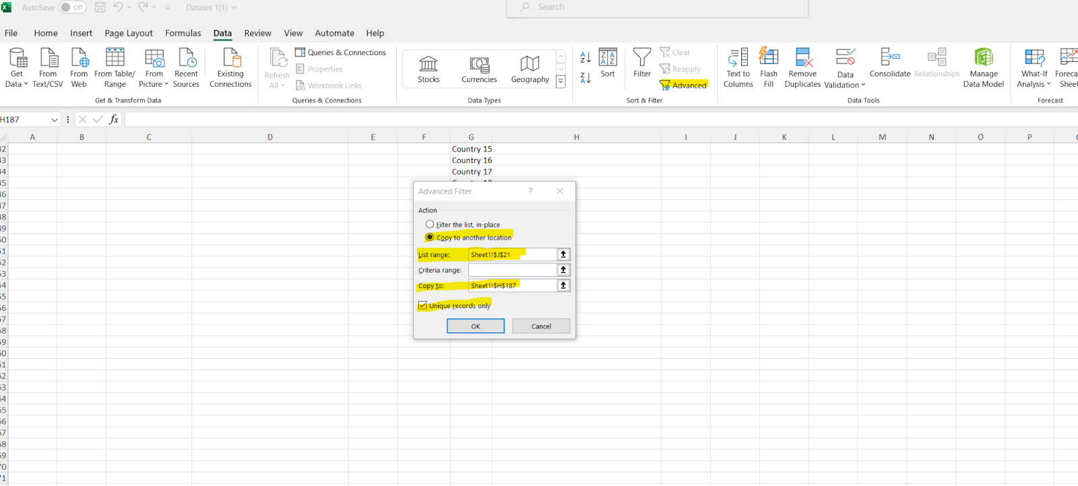

Once this is completed, we will have a unique record for both dataset 1 and dataset 2. We will be able to see all unique records for the categorical variables that we have. This is a vital step since both datasets may look similar, but they have different records that are unique to their respective file. Without using this approach there will be many errors in the data moving forward with analyzing the data.

**Dataset1:**

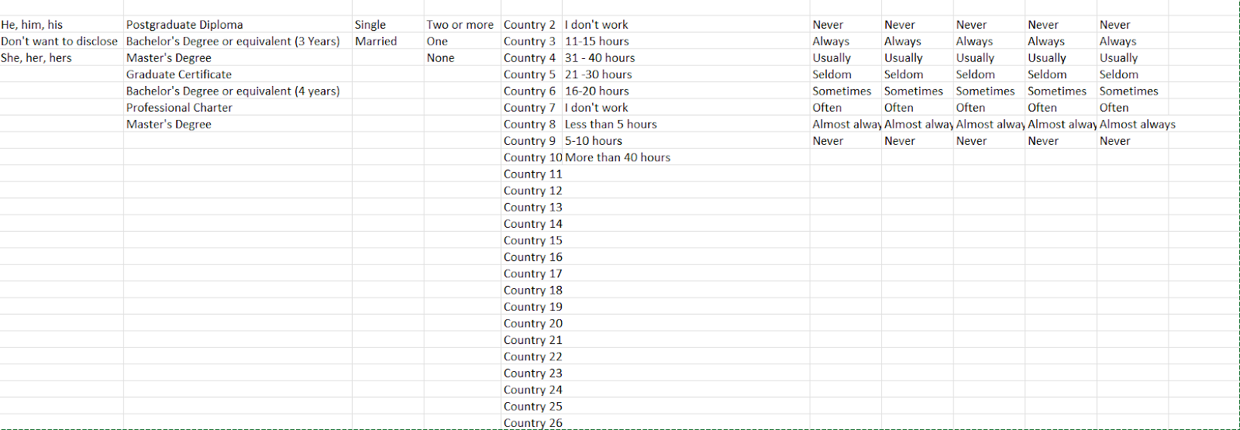

**Dataset 2:**

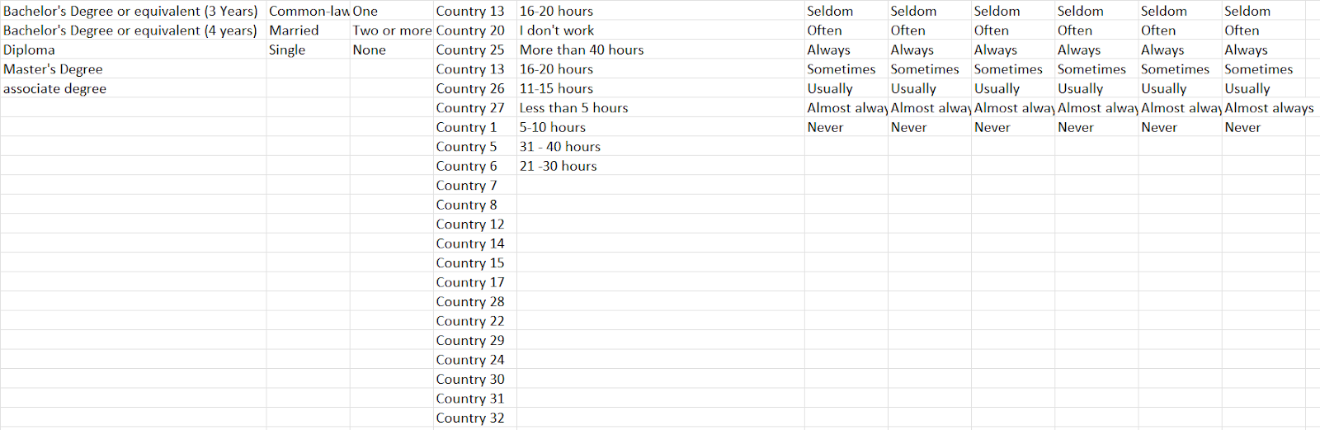

Once we have these two separated we are able to create our codebook by assembling the similarities and differences alike into one guideline. Our SPSS names are shortened to simplify the full variable name. The full variable will be included in our Labels to explain what these variables are. Our coding instructions are directly related to the values in SPSS. Once we have completed these steps we are able to move forward with merging the data.

# **STEP 2: CONVERT EXCEL FILES INTO SPSS FILES AND MERGE THE 2 SPSS FILES**

**Convert Excel Files into SPSS Files**

File > Data > Import Data > Excel > Choose excel file > Check first tick box: “Read variable names from first row of data” > Okay

**Change Display Variables To Display Names And Labeling To Display Both Values And Labels**

Edit > Options > Under “General tab – Variable Lists”, select “Display names” > Under “Output tab – Outline labeling and pivot table labeling”, select “Values and labels” > Okay

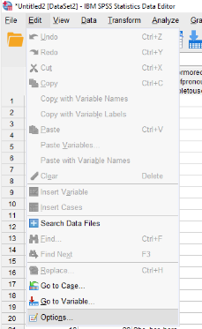 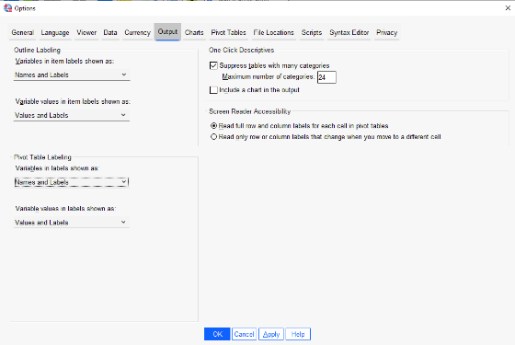

**In Preparation For Merging Both Excel Files, Check Variables From Both Files If They Are The Same**

* *Variable “V7” (imported from DataSet2) must be changed to “What is your country of origin” (as it is named in DataSet1)*

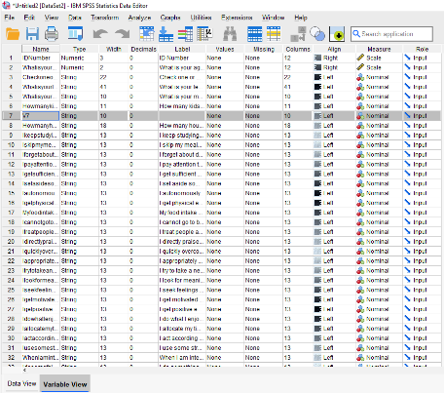 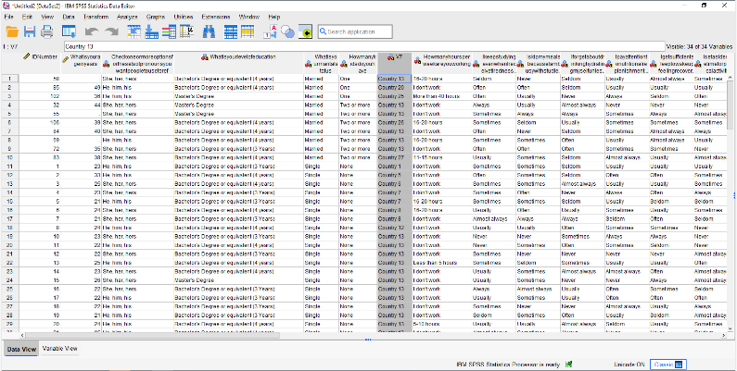

**Merge 2 Files Into 1 (Case/Data Points – MUST HAVE SAME VARIABLES IN BOTH FILES):**

* **Substep 1: Sort**

Data > Sort cases > choose “id number” > click arrow-in > choose sort order (i.e. ascending or descending) > Okay

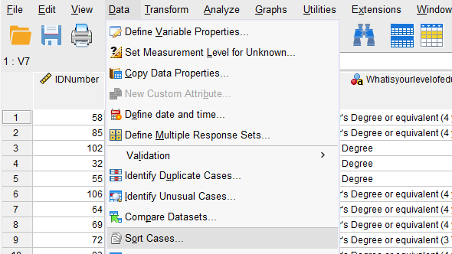 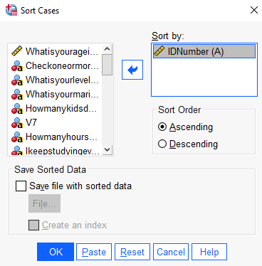

***There are missing ID numbers in one file – fix them manually***

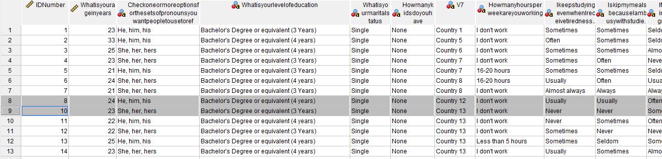

* **Substep 2: Transform the data (Merge Dataset 1 into Dataset 2)**

Transform > compute variable > under target variable: put “IDNumber” > select “IDNumber” and click arrow-in > under numeric expression: PRESS “+ 107 *(the last id no of DataSet2)* - 1 *(since the id no in DataSet1 started at 2)*” >

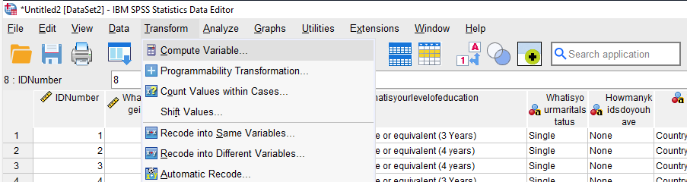 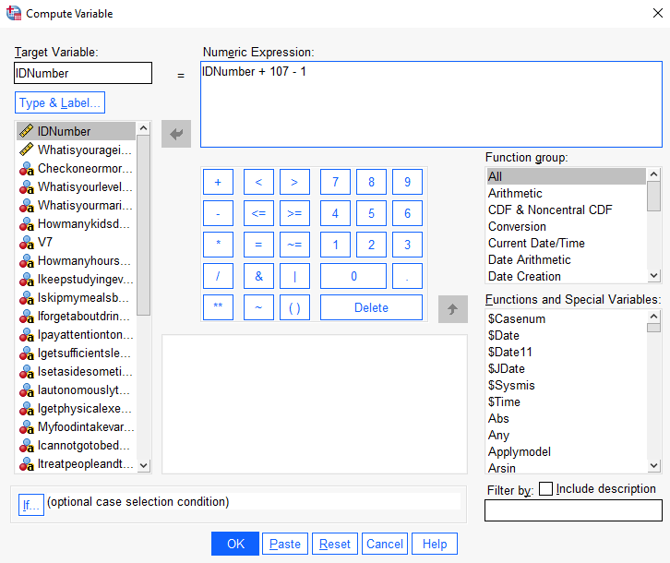

**End of DataSet2: Start of DataSet1:**

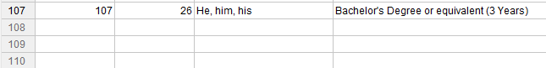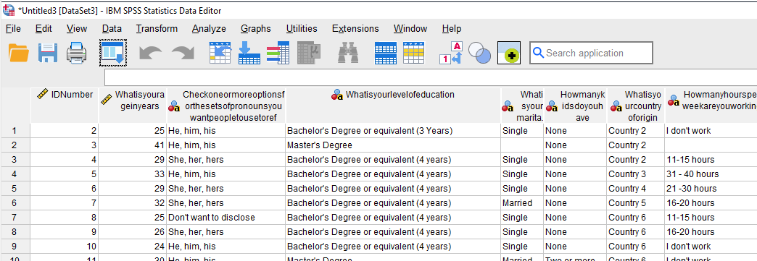

* **Substep 3: Merge files by case/data points**

Data > Merge Files > Add CASES > If both files are open, tick the “an open dataset” option. If one is closed, tick the “an external SPSS Statistics data file” option. > Continue > Okay

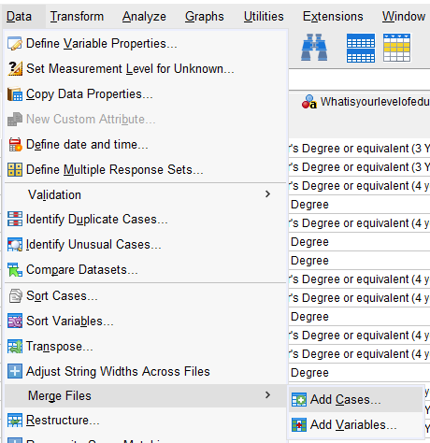 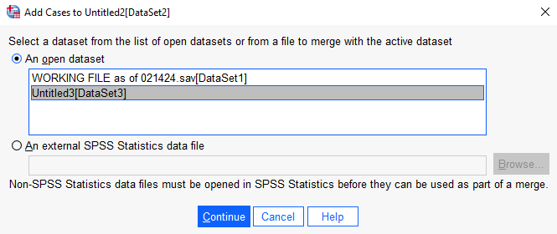 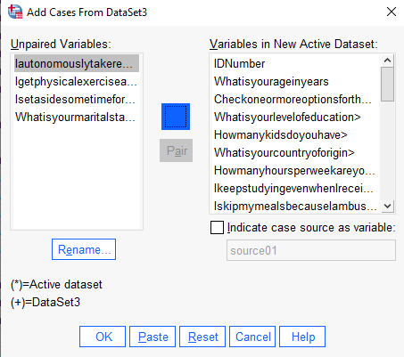

* **Substep 4: Save merged file**

File > Save As > .sav – you are saving a data file (data can be edited)

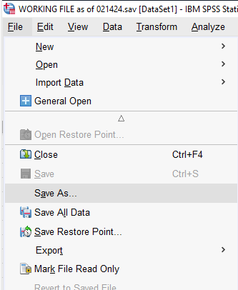 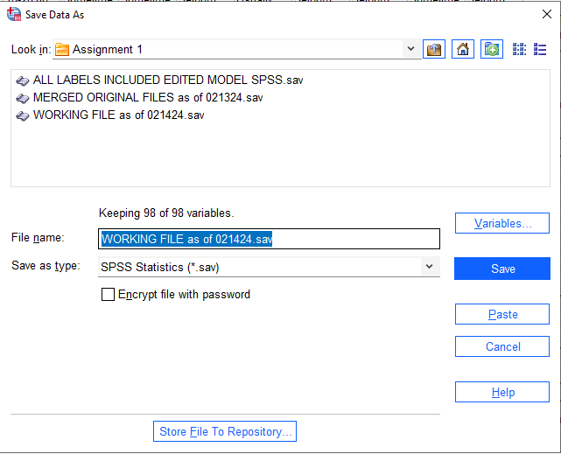

# **STEP 3: TRANSFORM/EXPLORE/CLEAN THE DATA**

**Automatic Recode**

Transform > automatic recode > select variable > enter a name > click “add new name” > okay

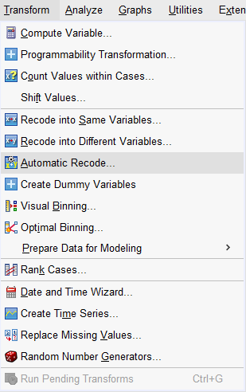 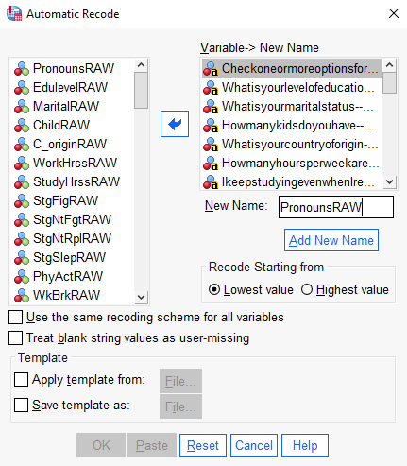 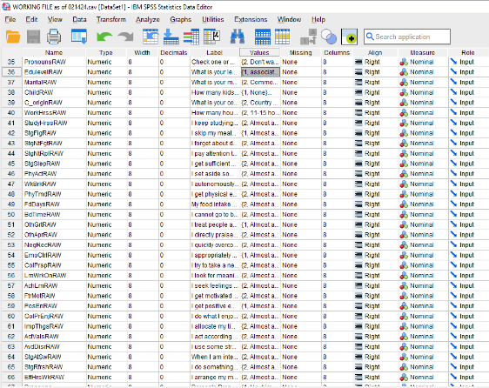

**Recode Into Different Variables**

Transform > recode into different variables > select variable > enter a name and label > change > click “old and new values” > replace old value with new values > continue > okay > check new variable created in “variable view” (at the end of all the variables) > edit “values” based on codebook >

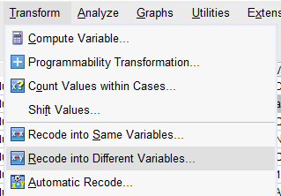

* **Substep 1: Pronouns**

After automatic recode, recode 3 into 1, 4 into 2, and 2 into 3

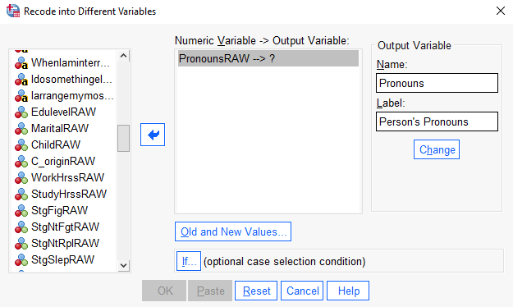 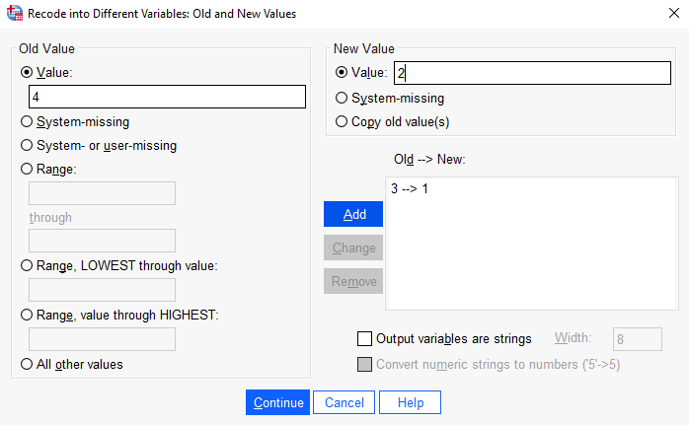



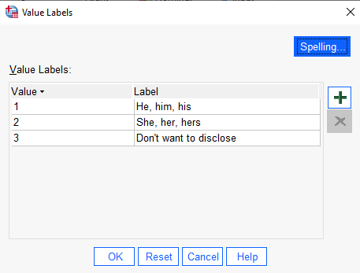

* **Substep 2: Edulevel**

After automatic recode, recode

|  |  |  |
| --- | --- | --- |
| **4** | **INTO** | **1** |
| **1** | **INTO** | **2** |
| **2** | **INTO** | **3** |
| **3** | **INTO** | **4** |
| **5** | **INTO** | **5** |
| **7** | **INTO** | **6** |
| **8** | **INTO** | **7** |
| **6** | **INTO** | **8** |

* **Substep 3: Marital**

After automatic recode, recode 4 into 1, 3 into 2, 2 into 3

* **Substep 4: Country of Origin**

After automatic recode, recode

|  |  |  |
| --- | --- | --- |
| **2** | **INTO** | **1** |
| **3** | **INTO** | **10** |
| **4** | **INTO** | **11** |
| **5** | **INTO** | **12** |
| **6** | **INTO** | **13** |
| **7** | **INTO** | **14** |
| **8** | **INTO** | **15** |
| **9** | **INTO** | **16** |
| **10** | **INTO** | **17** |
| **11** | **INTO** | **18** |
| **12** | **INTO** | **19** |
| **13** | **INTO** | **2** |
| **14** | **INTO** | **20** |
| **15** | **INTO** | **21** |
| **16** | **INTO** | **22** |
| **17** | **INTO** | **23** |
| **18** | **INTO** | **24** |
| **19** | **INTO** | **25** |
| **20** | **INTO** | **26** |
| **21** | **INTO** | **27** |
| **22** | **INTO** | **28** |
| **23** | **INTO** | **29** |
| **24** | **INTO** | **3** |
| **25** | **INTO** | **30** |
| **26** | **INTO** | **31** |
| **27** | **INTO** | **32** |
| **28** | **INTO** | **4** |
| **29** | **INTO** | **5** |
| **30** | **INTO** | **6** |
| **31** | **INTO** | **7** |
| **32** | **INTO** | **8** |
| **33** | **INTO** | **9** |

* **Substep 5: WorkHrss**

After automatic recode, recode

|  |  |  |
| --- | --- | --- |
| **7** | **INTO** | **1** |
| **8** | **INTO** | **2** |
| **6** | **INTO** | **3** |
| **2** | **INTO** | **4** |
| **3** | **INTO** | **5** |
| **4** | **INTO** | **6** |
| **5** | **INTO** | **7** |
| **9** | **INTO** | **8** |

* **Substep 6: PE1, PE3, PE4, PE5, PE6, PE7, PE8, PE9, PE10, EE3, EE5, SE1, SE2, SE3, SE5, SE6, SE7, ME1, ME2, ME3, ME4**

After automatic recode, recode

|  |  |  |
| --- | --- | --- |
| **4** | **INTO** | **1** |
| **6** | **INTO** | **2** |
| **7** | **INTO** | **3** |
| **8** | **INTO** | **4** |
| **5** | **INTO** | **5** |
| **2** | **INTO** | **6** |
| **3** | **INTO** | **7** |

* **Substep 7: PE2, EE1, EE4, SE4**

After automatic recode, recode

|  |  |  |
| --- | --- | --- |
| **3** | **INTO** | **1** |
| **5** | **INTO** | **2** |
| **6** | **INTO** | **3** |
| **7** | **INTO** | **4** |
| **4** | **INTO** | **5** |
| **1** | **INTO** | **6** |
| **2** | **INTO** | **7** |

* **Substep 8: EE2**

After automatic recode, recode

|  |  |  |
| --- | --- | --- |
| **1** | **INTO** | **1** |
| **5** | **INTO** | **2** |
| **6** | **INTO** | **3** |
| **7** | **INTO** | **4** |
| **4** | **INTO** | **5** |
| **2** | **INTO** | **6** |
| **3** | **INTO** | **7** |

For proper referencing with the original question numbers, the newly recoded variable names we will be using are as follows:

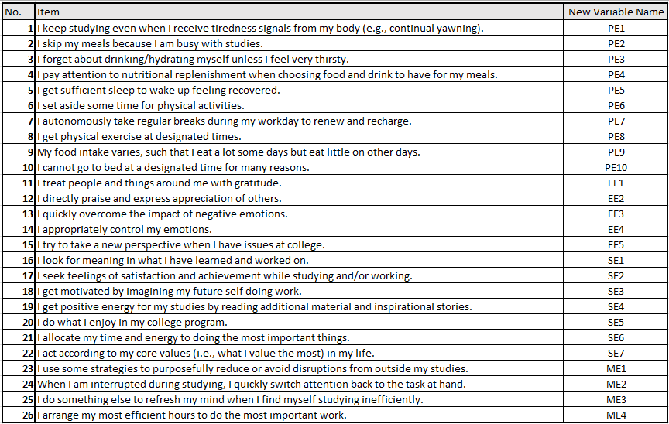

**Detect And Correct Errors In The Dataset (CLEANING):**

For Nominal and Ordinal: Analyze > Descriptive Statistics > Frequencies > Choose Variables > Select “Statistics” > Under “Dispersion”, select “minimum” and “maximum”> Continue > Okay

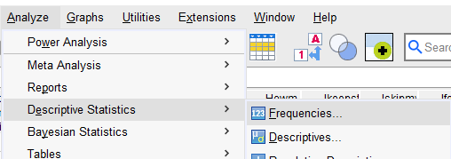 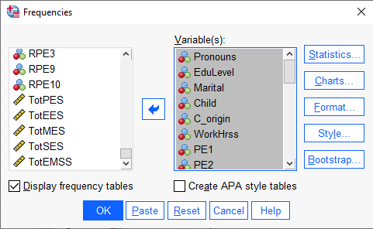 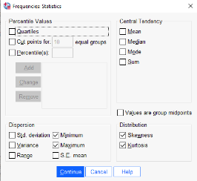

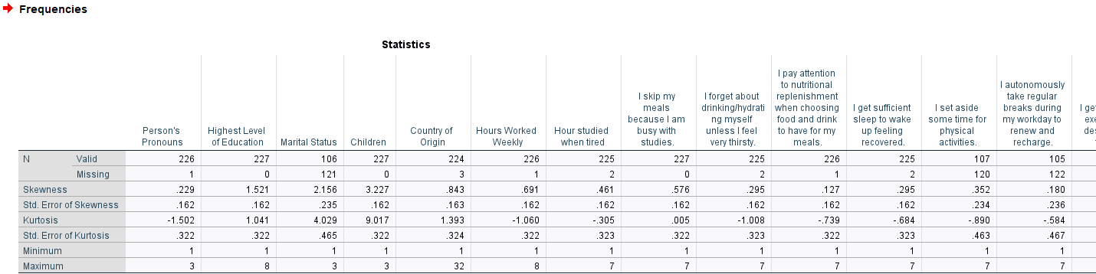

For Scale (Continuous): Analyze > Descriptive Statistics > Descriptives > Choose Variables that are scale in measure > Select “Options” > Under “Dispersion”, select “minimum” and “maximum”> Continue > Okay

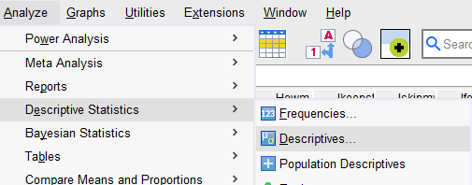 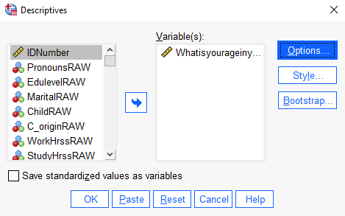 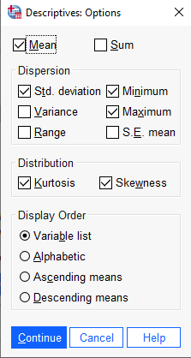

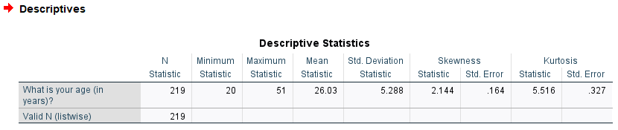

***The data is clean – every input provided by respondents are within the range given by the codebook.***

**Preliminary Tests for Normality (for continuous variable) and Reliability of the Scale (for scale questions)**

**Tests for Normality**

Analyze > Descriptive Statistics > Explore > pick and choose variables > Statistics > check Outliers > continue > Plots > check Normality Plots with Tests > continue > Options > check Exclude Cases Pairwise > continue > Check Both > Okay and look at histograms, box plots, mean, trimmed mean, etc.

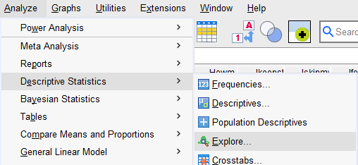 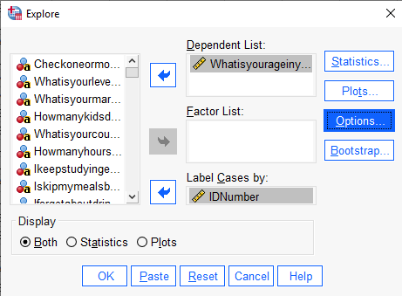

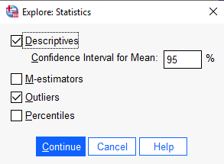 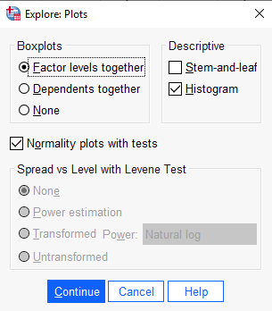 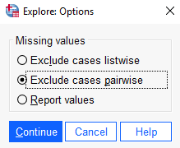

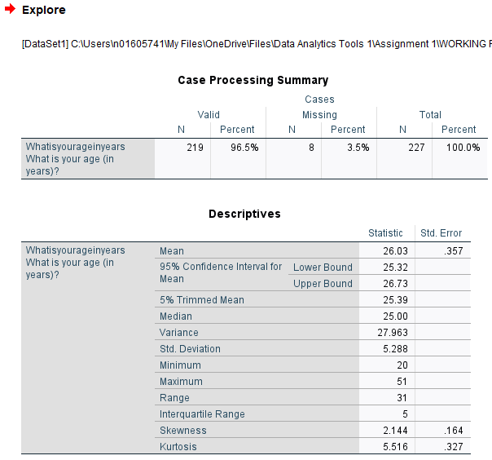 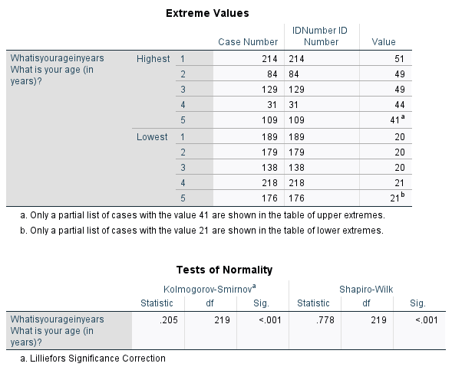

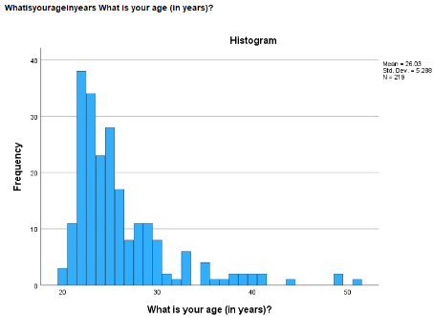 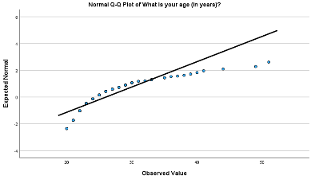 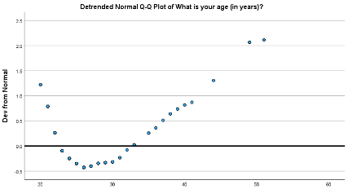 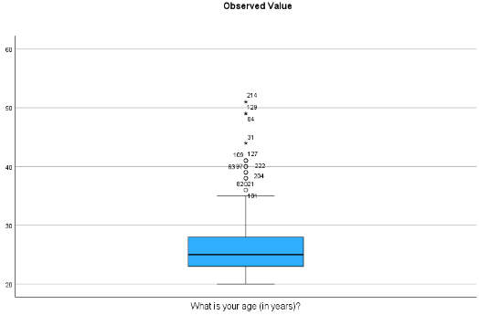 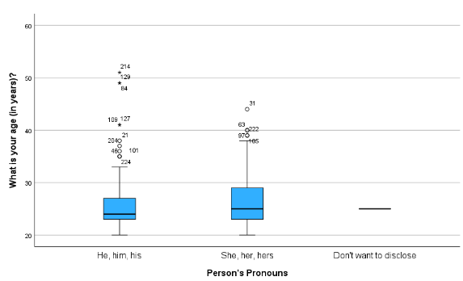

***ANALYSIS:*** *K-S significance value is* ***LESS than 0.05*** *=* ***SIGNIFICANT RESULT*** *=* ***reject the null hypothesis*** *=* ***NOT NORMAL DISTRIBUTION****.*

*The continuous variable “****age****” is* ***not normally distributed*** *– even when split for men and women.*

**Tests for Reliability of Scale**

Analyze > scale > reliability analysis > select variables to “item” > in “model”, select “alpha” > enter scale label > statistics > under “descriptives for”, select “scale” and “scale if item deleted” > under “summaries” and “inter item”, select “correlation” > continue > okay

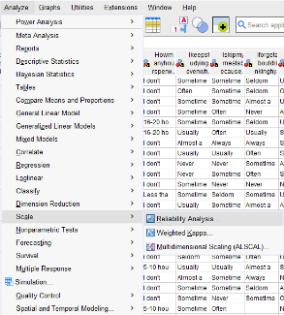 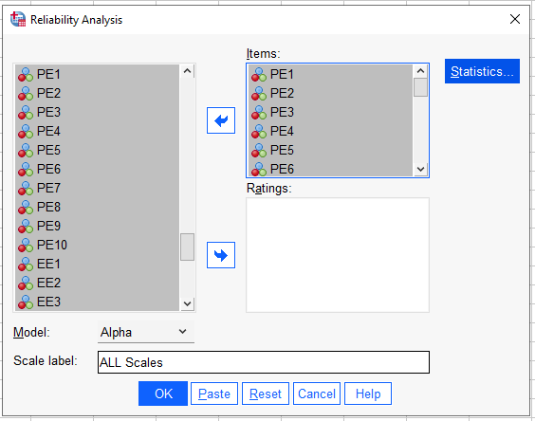 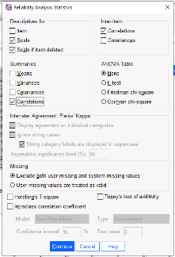

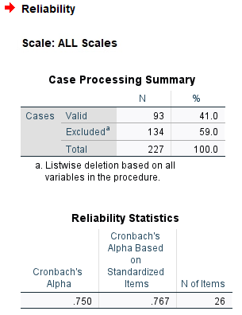 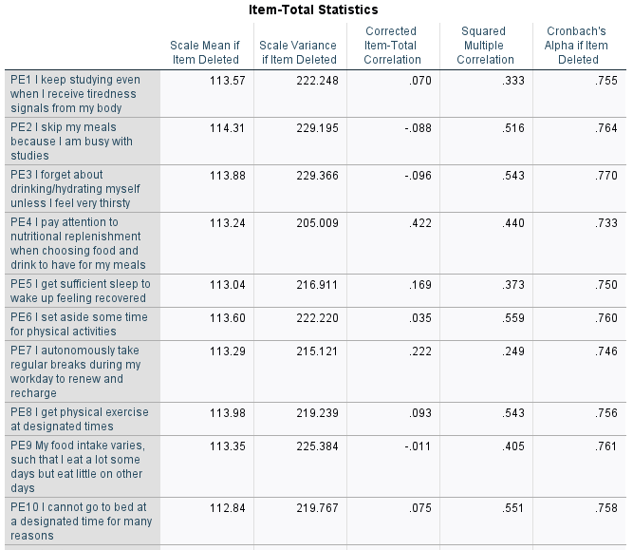 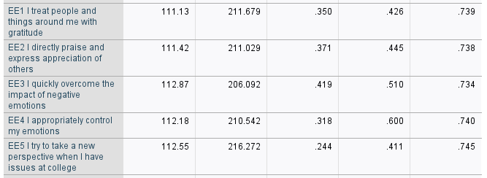 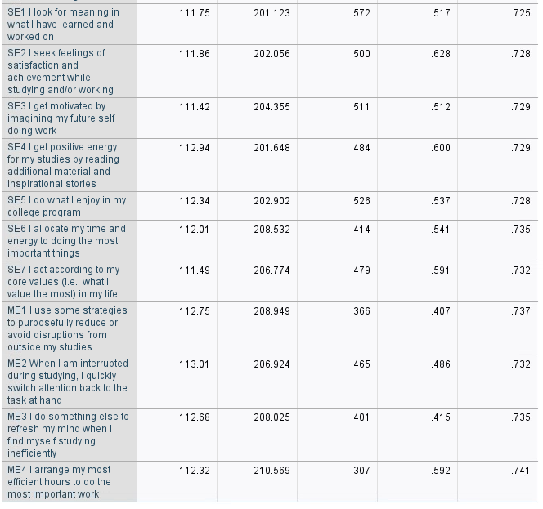

***ANALYSIS: Cronbach’s Alpha*** *for the entire scale is already acceptable* ***at .750****.* ***However, there are still items in the scale that have a negative corrected item-total correlation that, if removed or reversed, would result in a higher Cronbach’s Alpha value*** *(Step 4).*

# **STEP 4: DATA MANIPULATION AND DESCRIPTIVE ANALYSIS**

**Collapse The Number Of Categories For Age, EduLevel, Marital, Child, and WorkHrss**

Transform > recode into different variables > select variable > enter a name and label > change > click “old and new values” > replace old value with new values > continue > okay > check new variable created in “variable view” (at the end of all the variables) > update codebook > edit “values” based on codebook

* **Substep 1: Age**

Collapse Age into 3 groups (AgeGrp3):

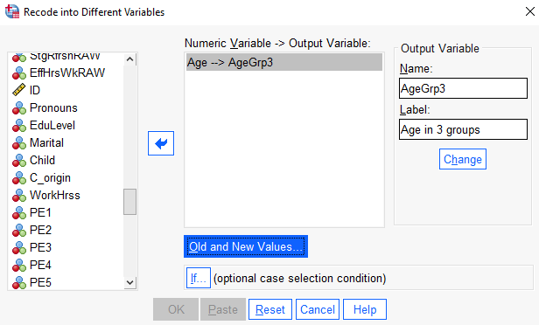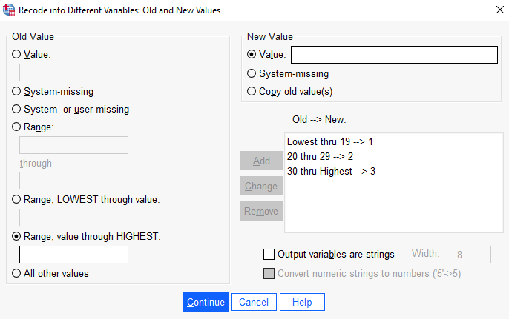



* **Substep 2: EduLevel**

Collapse EduLevel into 2 groups (EduLevelGrp2):





* **Substep 3: Marital**

Collapse Marital into 2 groups (MaritalGrp2):





* **Substep 4: Child**

Collapse Child into 2 groups (ChildGrp2):





* **Substep 5: WorkHrss**

Collapse WorkHrss into 3 groups (WorkHrssGrp3):





* **Substep 6: Check and run descriptives on newly made variables**

For Nominal and Ordinal: Analyze > Descriptive Statistics > Frequencies > Choose Variables > Select “Statistics” > Under “Dispersion”, select “minimum” and “maximum”> Continue > Okay

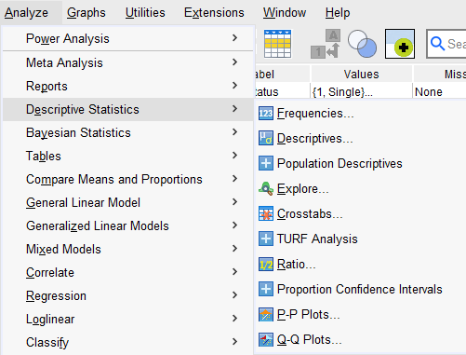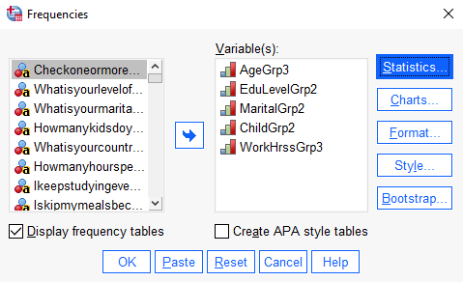

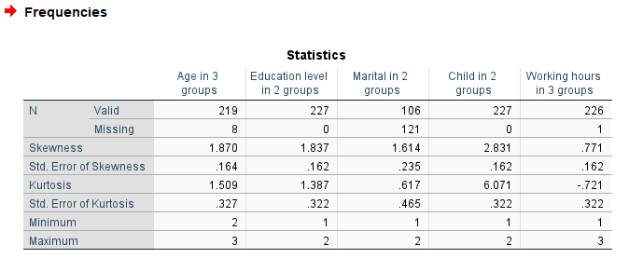

***ANALYSIS: All newly created grouped variables fall within an acceptable range***

**Check And Replace Any Negative Worded Items/Questions**

**Identifying negatively stated questions:**

*We have identified 5 negatively stated questions from the survey. These are all aligned with the negative and low Cronbach’s Alpha scores from the previous step:*

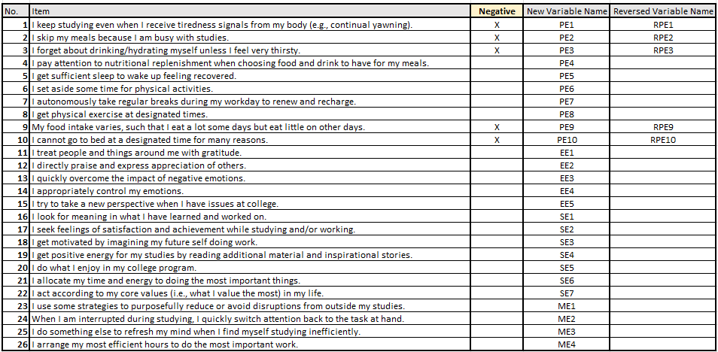

**Transforming negatively stated questions:**

Transform > Recode into different variables   
> select variables you want to reverse to input variable/output variable box area > select variable to reverse in the input variable/output variable box area > set a new “reverse” name in the name pane and add a “reverse” label in the label pane > click change > press “old and new values” button > change and invert values on Lickert scale > continue > okay > check if you successfully created the new variables by checking the bottom of your variable list (in variable view) > update “values” of the new variables > update codebook with new variables.

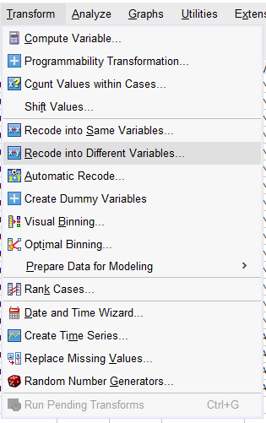 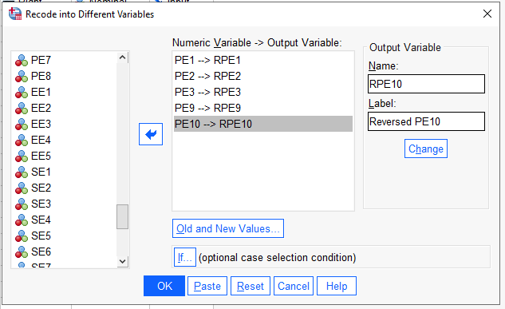 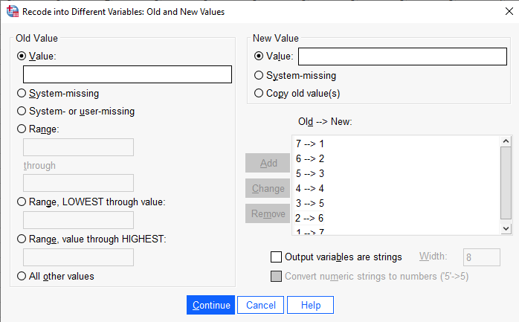

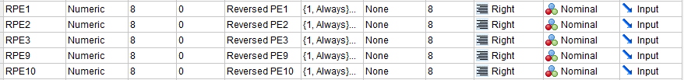

**Test Reliability Scale Again Using Newly Reversed Variables**

Analyze > scale > reliability analysis > select variables to “item” > in “model”, select “alpha” > enter scale label > statistics > under “descriptives for”, select “scale” and “scale if item deleted” > under “summaries” and “inter item”, select “correlation” > continue > okay

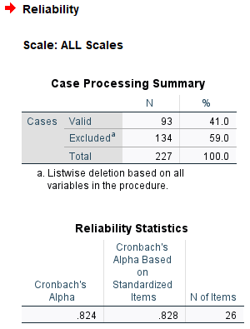 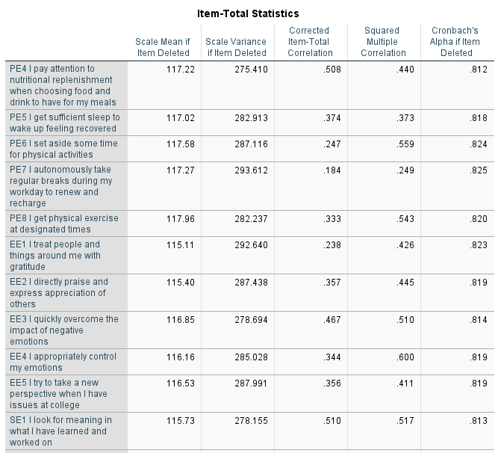

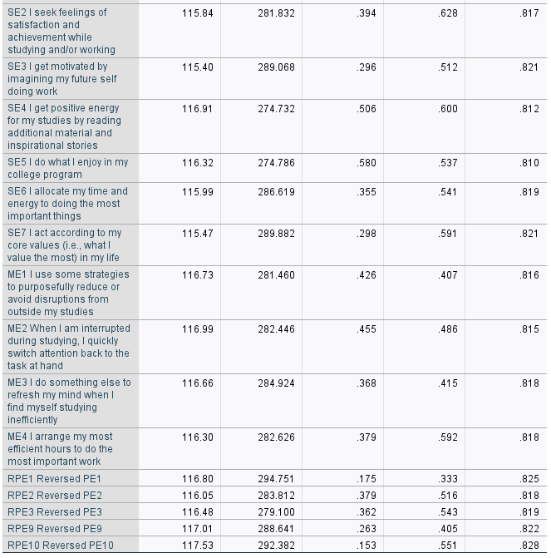

***ANALYSIS: Cronbach’s Alpha*** *for the entire scale is* ***now even higher at .824****, showing that the* ***reversed items in the scale enhanced the scale’s overall reliability****. Thus, we now* ***use the reversed variables in place of the original ones*** *from this point on.*

# **STEP 5: ADD THE SCORES + CREATE THE INDIVIDUAL SUMMATED SCALES AND TOTAL SUMMATED ENERGY MANAGEMENT SKILLS SCALE**

Based on the article by Zhang, Tong, Huo (2018) titled *Development of the Energy Management Scale*, we follow the same procedure they did and criteria they had to classify which items/questions to include in the individual and total summated energy management scales:

* **Substep 1: From the preliminary reliability analysis conducted above, we identify which items/questions belong to which individual energy management scale:**

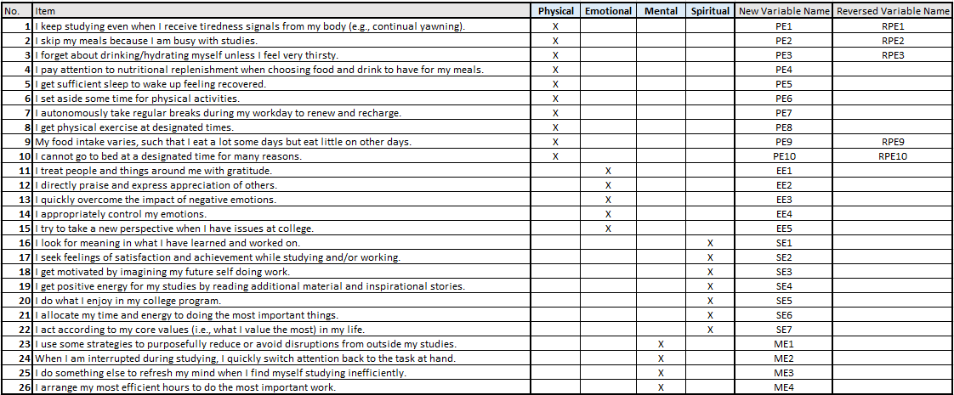

* **Substep 2: We then use the items/questions that the article used for their reliability analysis, which are as follows:**

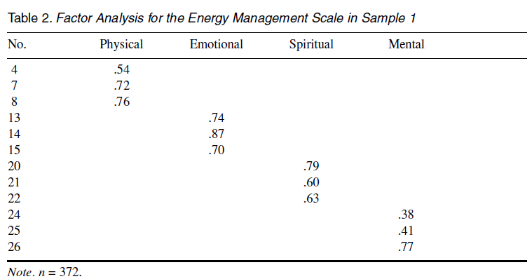

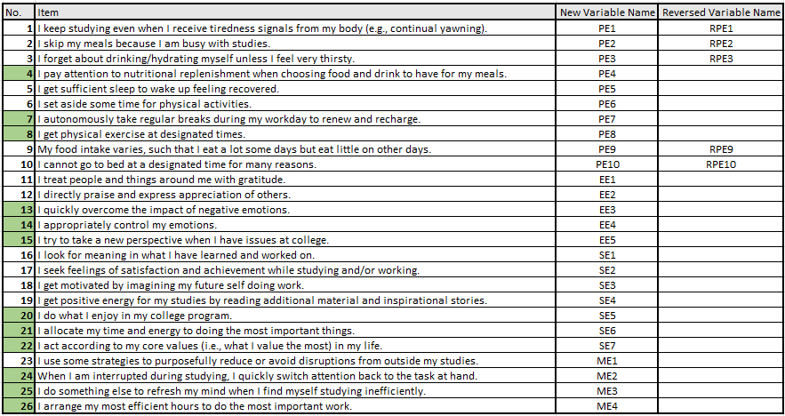

**Total Physical Energy**

Transform > Compute Variable > under “target variable”, type new variable (**TotPES3**) > click on the “type and label” button > fill in label (“**Total Physical Energy Skill (3-item)**”) > continue > add all variables (items based on sample 1 that is classified as Physical Energy – **PE4, PE7, PE8**) > Okay > Update codebook.

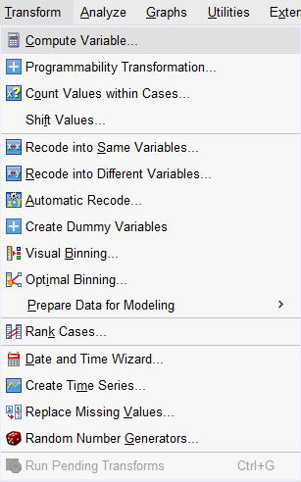 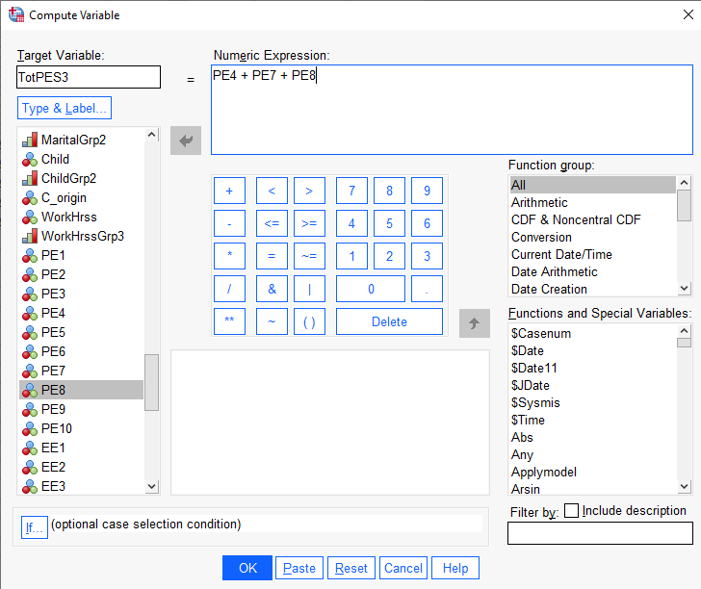

**Total Emotional Energy**

Transform > Compute Variable > under “target variable”, type new variable (**TotEES3**) > click on the “type and label” button > fill in label (“**Total Emotional Energy Skill (3-item)**”) > continue > add all variables (items based on sample 1 that is classified as Emotional Energy – **EE3, EE4, EE5**) > Okay > Update codebook.

 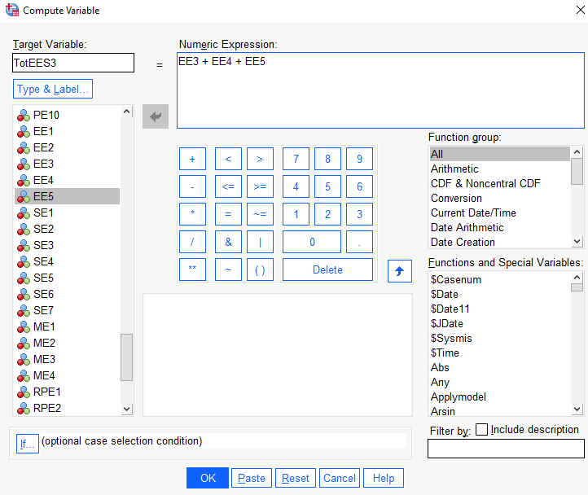

**Total Mental Energy**

Transform > Compute Variable > under “target variable”, type new variable (**TotMES3**) > click on the “type and label” button > fill in label (“**Total Mental Energy Skill (3-item)**”) > continue > add all variables (items based on sample 1 that is classified as Mental Energy – **ME2, ME3, ME4**) > Okay > Update codebook.

 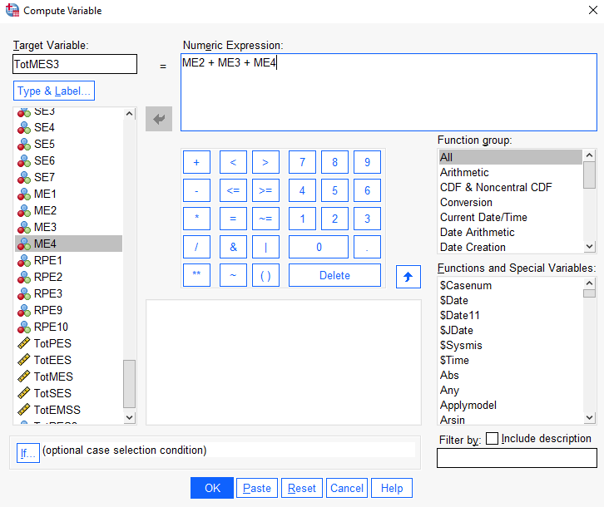

**Total Spiritual Energy**

Transform > Compute Variable > under “target variable”, type new variable (**TotSES3**) > click on the “type and label” button > fill in label (“**Total Spiritual Energy Skill (3-item)**”) > continue > add all variables (items based on sample 1 that is classified as Mental Energy – **SE5, SE6, SE7**) > Okay > Update codebook.

 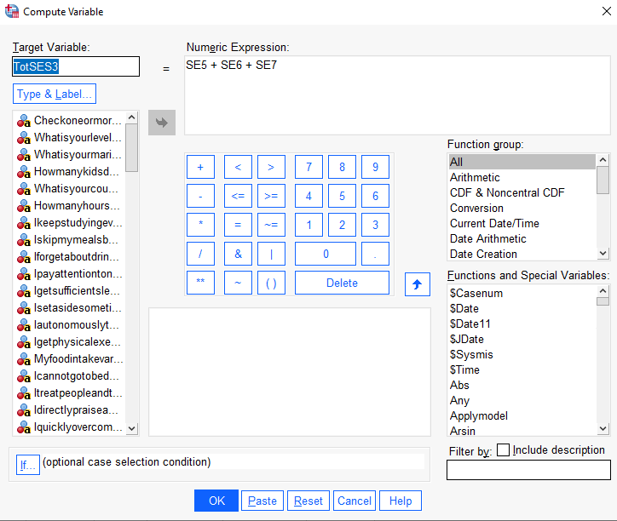

**Total Summated Energy Management Skill**

Transform > Compute Variable > under “target variable”, type new variable (**TotEMSS3**) > click on the “type and label” button > fill in label (“**Total Energy Management Skill (3-item)**”) > continue > add all variables (Total summated of all energy skills above – **TotPES3, TotEES3, TotMES3, TotSES3**) > Okay > Update codebook.

 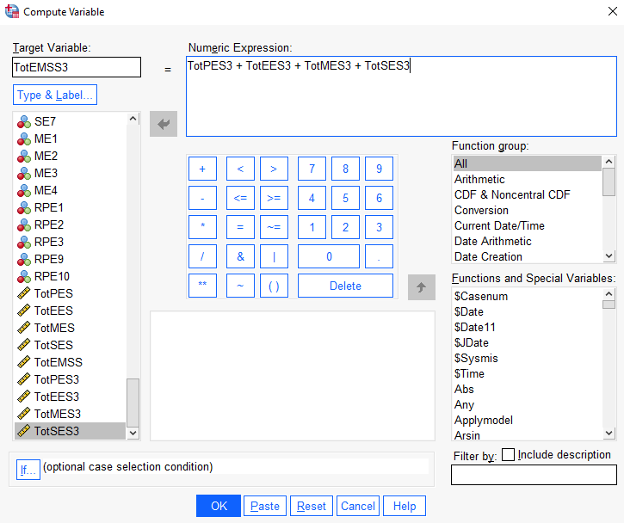

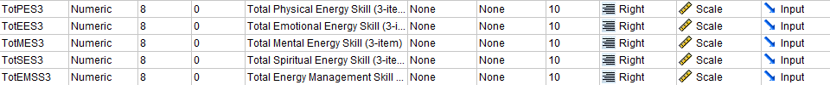

# **STEP 6: CONDUCT RELIABILITY ANALYSIS FOR EACH OF THE SCALE**

*In the previous step, we have created the total scores (3-items) for each energy management skills and the total summated energy scales. Now we need to do Reliability Analysis for each energy skill and the total summated scales.*

**Tests for Reliability of Scale (Physical Energy – 3-items)**

Analyze > scale > reliability analysis > select variables (**PE4, PE7, PE8**) to “item” > in “model”, select “alpha” > enter scale label > statistics > under “descriptives for”, select “scale” and “scale if item deleted” > under “summaries” and “inter item”, select “correlation” > continue > okay

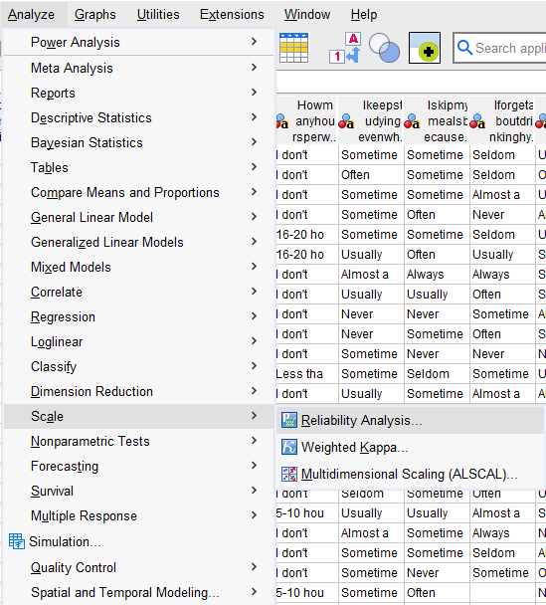 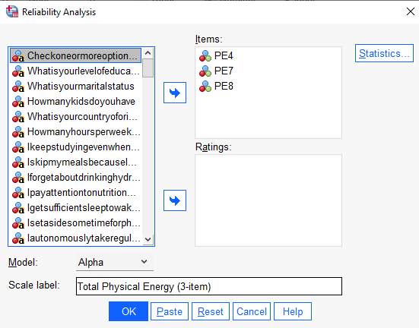 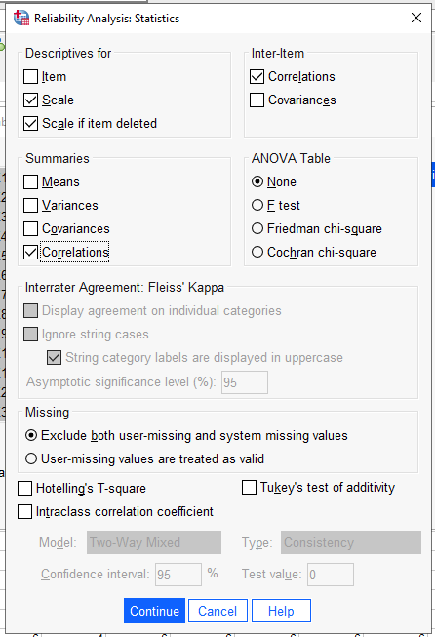

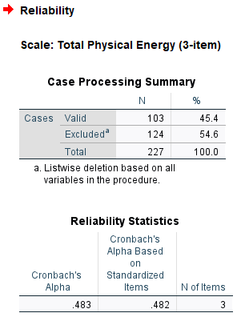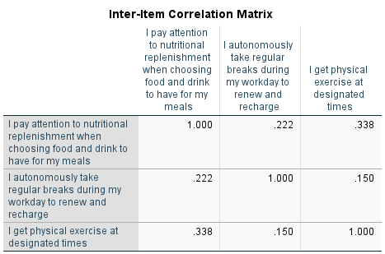

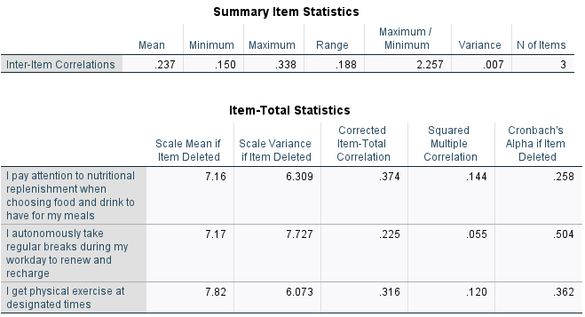

***ANALYSIS:*** *The acceptable figure for Cronbach’s Alpha, which shows whether items in the scale measure the same construct, is .7 and above. The acceptable figure for the mean inter-item correlation is acceptable between .2 to .4. The acceptable figure for corrected total item correlation is .3 and above.*

***Cronbach’s Alpha for the Total Physical Energy scale is NOT acceptable at .483****. Meanwhile, its* ***mean inter-item correlation is acceptable at .237****. Thus,* ***we use the mean inter-item correlation instead****. It can also be seen that 2 out of 3 corrected total item correlations are above .3.*

**Tests for Reliability of Scale (Emotional Energy – 3-items)**

Analyze > scale > reliability analysis > select variables (**EE3, EE4, EE5**) to “item” > in “model”, select “alpha” > enter scale label > statistics > under “descriptives for”, select “scale” and “scale if item deleted” > under “summaries” and “inter item”, select “correlation” > continue > okay

 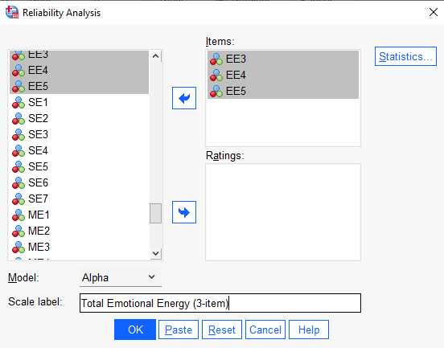 

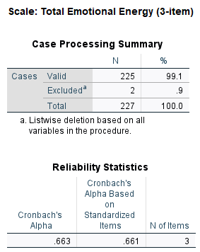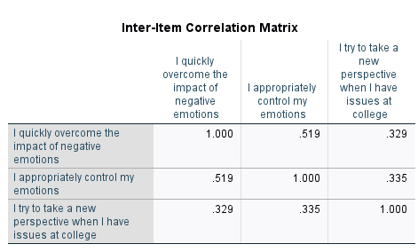

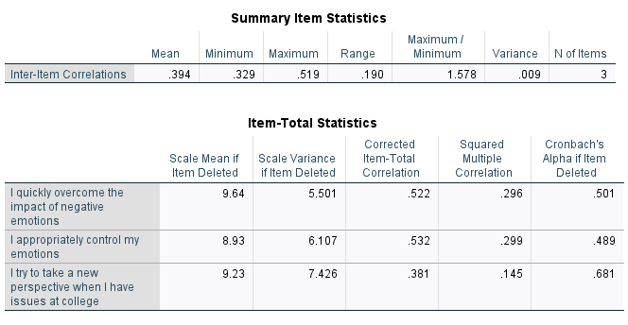

***ANALYSIS:*** *The acceptable figure for Cronbach’s Alpha, which shows whether items in the scale measure the same construct, is .7 and above. The acceptable figure for the mean inter-item correlation is acceptable between .2 to .4. The acceptable figure for corrected total item correlation is .3 and above.*

***Cronbach’s Alpha for the Total Emotional Energy scale is NOT acceptable at .663.*** *Meanwhile, its* ***mean inter-item correlation is acceptable at .394****. Thus,* ***we use the mean inter-item correlation instead****. It can also be seen that all 3 corrected total item correlations are above .3.*

**Tests for Reliability of Scale (Mental Energy – 3-items)**

Analyze > scale > reliability analysis > select variables (**ME2, ME3, ME4**) to “item” > in “model”, select “alpha” > enter scale label > statistics > under “descriptives for”, select “scale” and “scale if item deleted” > under “summaries” and “inter item”, select “correlation” > continue > okay

 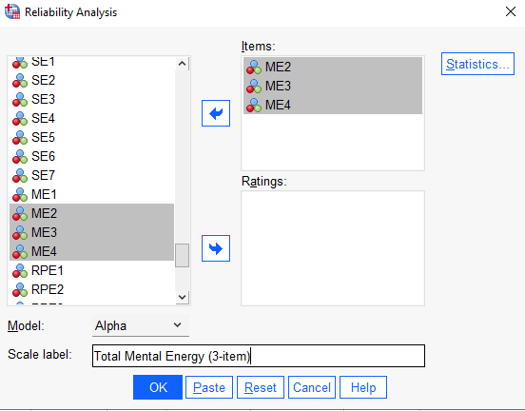 

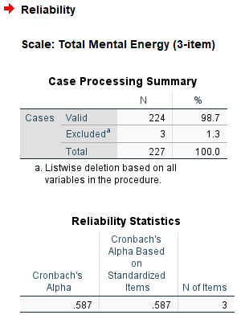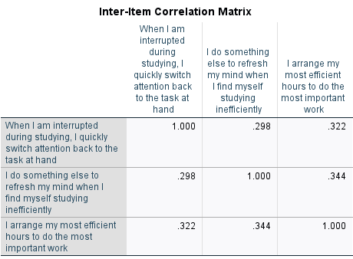

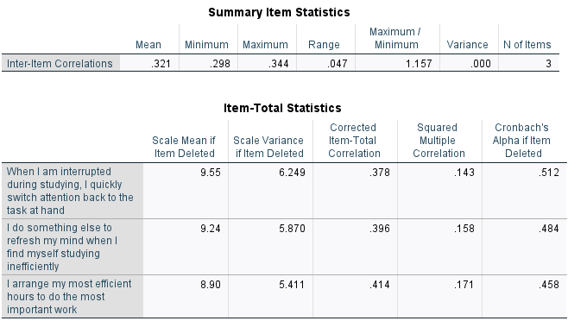

***ANALYSIS:*** *The acceptable figure for Cronbach’s Alpha, which shows whether items in the scale measure the same construct, is .7 and above. The acceptable figure for the mean inter-item correlation is acceptable between .2 to .4. The acceptable figure for corrected total item correlation is .3 and above.*

***Cronbach’s Alpha for the Total Mental Energy scale is NOT acceptable at .587****. Meanwhile, its* ***mean inter-item correlation is acceptable at .321****. Thus,* ***we use the mean inter-item correlation instead****.**It can also be seen that all 3 corrected total item correlations are above .3.*

**Tests for Reliability of Scale (Spiritual Energy – 3-items)**

Analyze > scale > reliability analysis > select variables (**SE5, SE6, SE7**) to “item” > in “model”, select “alpha” > enter scale label > statistics > under “descriptives for”, select “scale” and “scale if item deleted” > under “summaries” and “inter item”, select “correlation” > continue > okay

 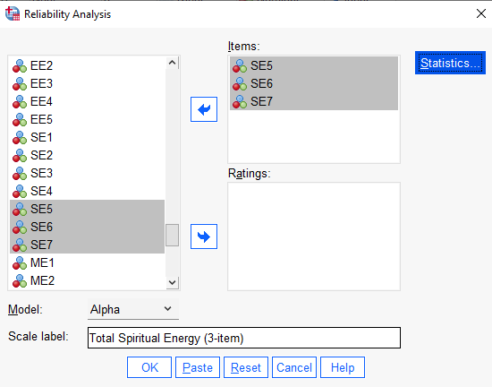 

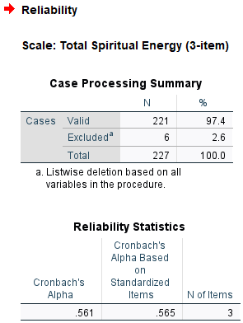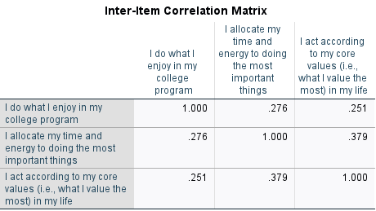

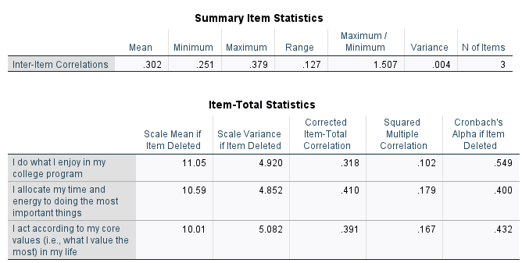

***ANALYSIS:*** *The acceptable figure for Cronbach’s Alpha, which shows whether items in the scale measure the same construct, is .7 and above. The acceptable figure for the mean inter-item correlation is acceptable between .2 to .4. The acceptable figure for corrected total item correlation is .3 and above.*

***Cronbach’s Alpha for the Total Spiritual Energy scale is NOT acceptable at .561****. Meanwhile, its* ***mean inter-item correlation is acceptable at .302****. Thus,* ***we******use the mean inter-item correlation instead****.**It can also be seen that all 3 corrected total item correlations are above .3.*

**Tests for Reliability of Scale (Total Summated Energy – 3-items)**

Analyze > scale > reliability analysis > select variables (**PE4, PE7, PE8, EE3, EE4, EE5, ME2, ME3, ME4, SE5, SE6, SE7**) to “item” > in “model”, select “alpha” > enter scale label > statistics > under “descriptives for”, select “scale” and “scale if item deleted” > under “summaries” and “inter item”, select “correlation” > continue > okay

 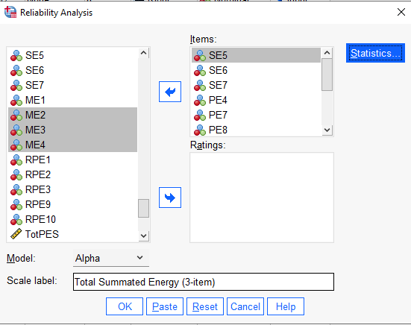 

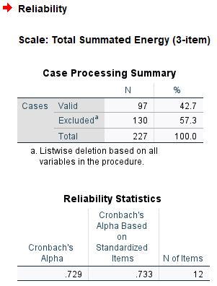

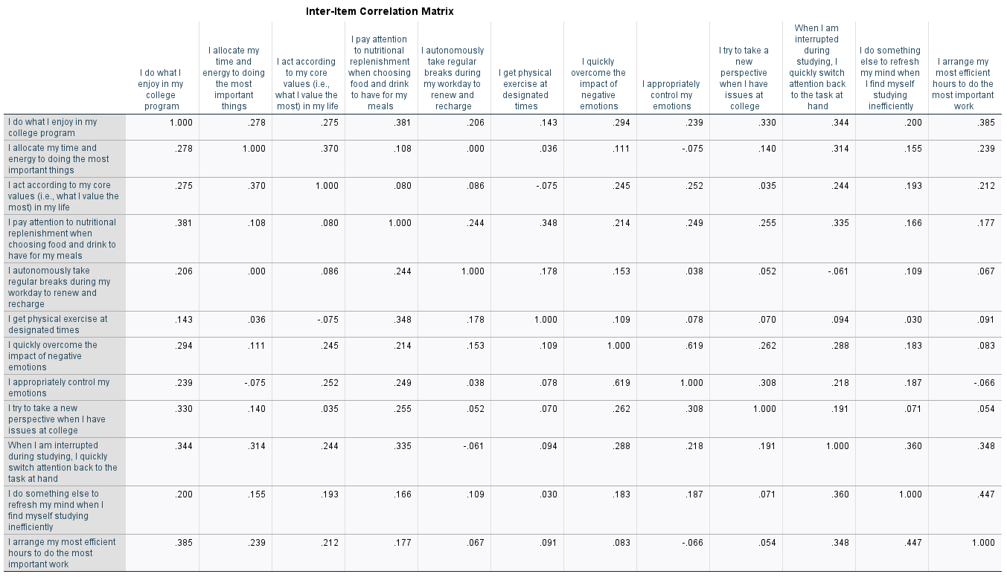

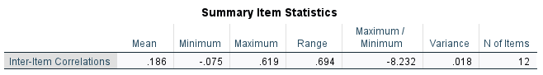

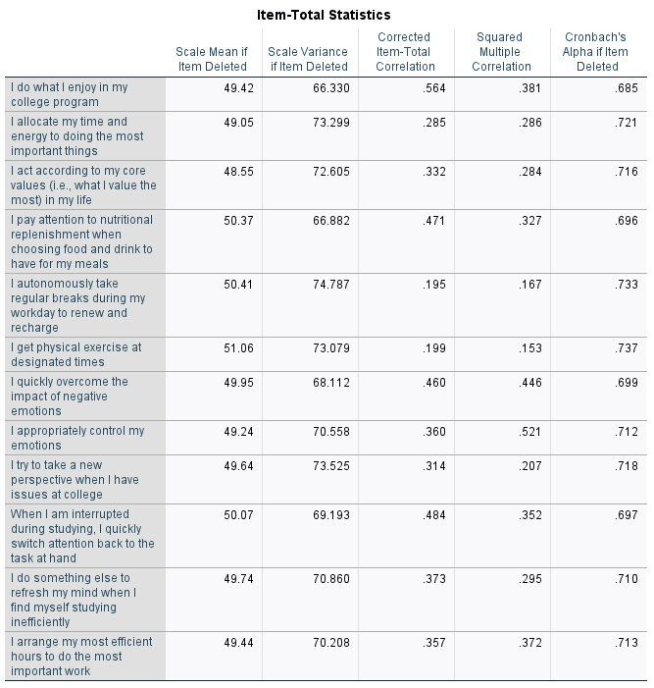

***ANALYSIS:*** *The acceptable figure for Cronbach’s Alpha, which shows whether items in the scale measure the same construct, is .7 and above. The acceptable figure for the mean inter-item correlation is acceptable between .2 to .4. The acceptable figure for corrected total item correlation is .3 and above.*

***Cronbach’s Alpha for the Total Summated Energy scale is now acceptable at .729****.* ***Thus, we use the Cronbach’s Alpha. The higher Cronbach’s Alpha figure is most likely due to the number of items in this summated scale being higher than 10 (as opposed to the individual scales which only contain 3 items/questions each).*** *It can also be seen that 9 out of 12 corrected total item correlations are above .3. On the other hand, its* ***mean inter-item correlation is now lower at .186****.*

# **STEP 7: CONDUCT TESTS FOR NORMALITY FOR EACH TOTAL SCORE**

**Tests for Normality (Total Physical Energy – 3-items)**

Analyze > Descriptive Statistics > Explore > pick and choose variables (**TotPES3**) > Statistics > check Outliers > continue > Plots > check Normality Plots with Tests > continue > Options > check Exclude Cases Pairwise > continue > Check Both > Okay and look at histograms, box plots, mean, trimmed mean, etc.

 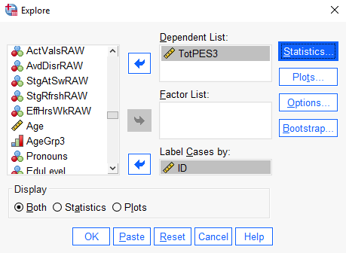

  

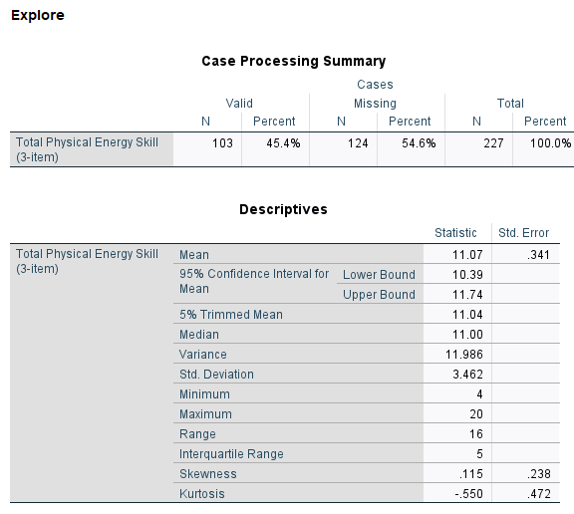 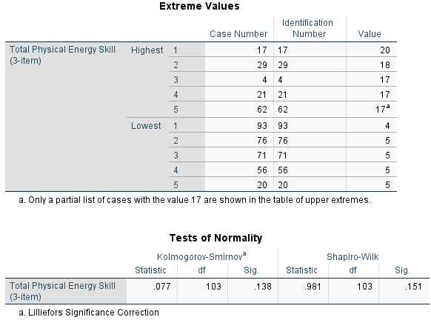

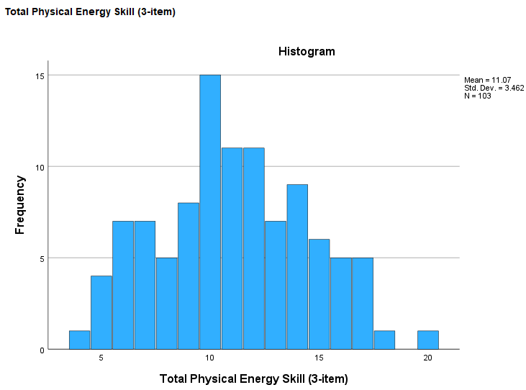 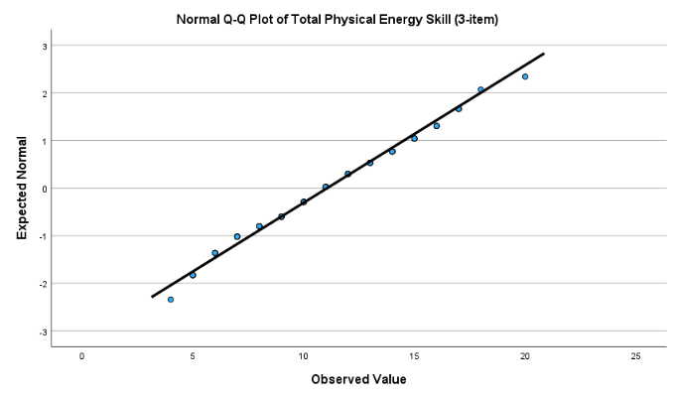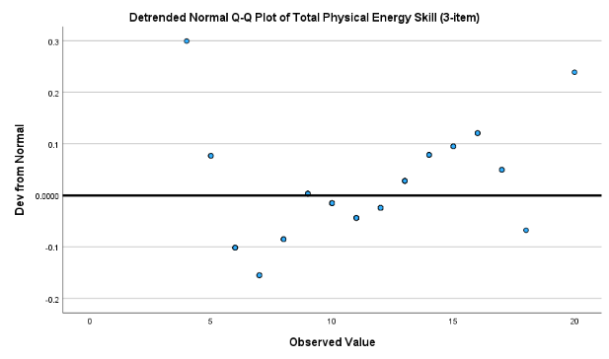 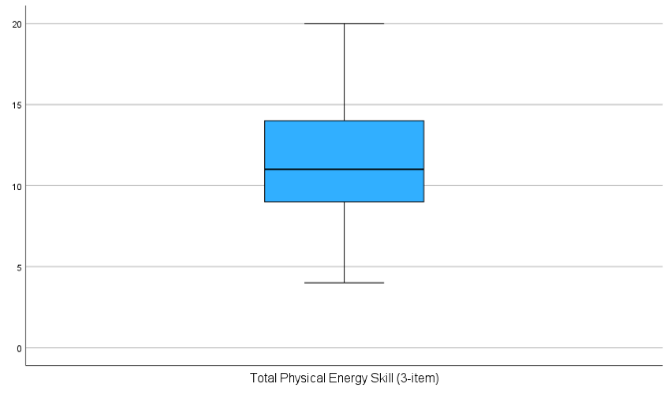

***ANALYSIS:*** *The difference between the 5% trimmed mean, which eliminates the top and bottom 5% of observations, and the* ***mean is not large at +0.03. This means that there are no outliers and extreme values*** *that dragged the mean either upward or downward.**This is also seen in the* ***box and whiskers plot, where there are no circles or stars above and below the whiskers****.* ***The kurtosis figures is negative at -0.550, indicating that the distribution is platykurtic – relatively flat distribution****. The* ***skewness is also positive at 0.115, indicating that the distribution is skewed to the right****. The* ***histogram shows that the distribution is slightly skewed to the right****. On the other hand, the* ***K-S significance value is HIGHER than the critical value of 0.05 at 0.138 = INSIGNIFICANT RESULT = do not reject the null hypothesis = NORMAL DISTRIBUTION****.*

***Thus, the individual scale “Total Physical Energy” is normally distributed****.*

**Tests for Normality (Total Emotional Energy – 3-items)**

Analyze > Descriptive Statistics > Explore > pick and choose variables (**TotEES3**) > Statistics > check Outliers > continue > Plots > check Normality Plots with Tests > continue > Options > check Exclude Cases Pairwise > continue > Check Both > Okay and look at histograms, box plots, mean, trimmed mean, etc.

 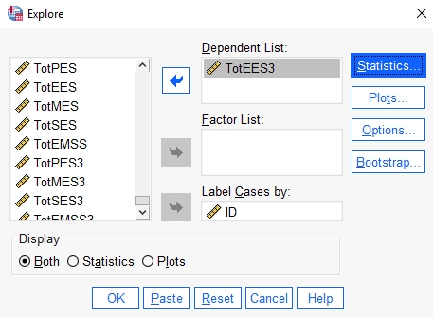

  

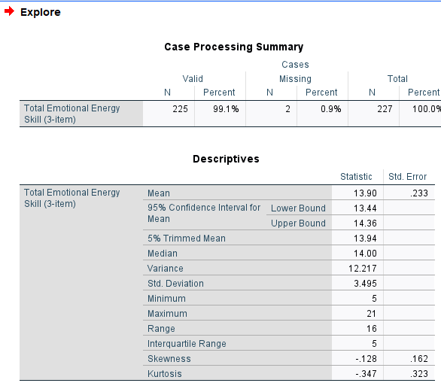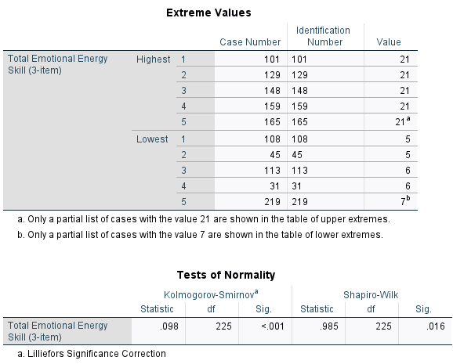

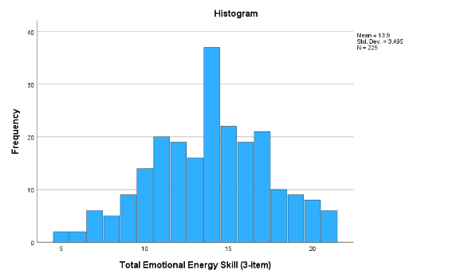 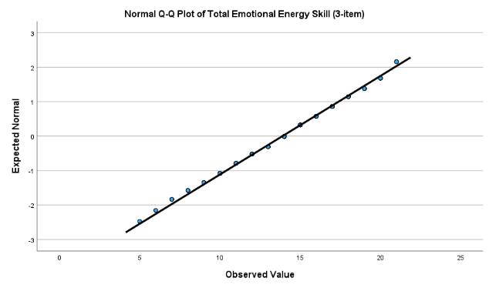

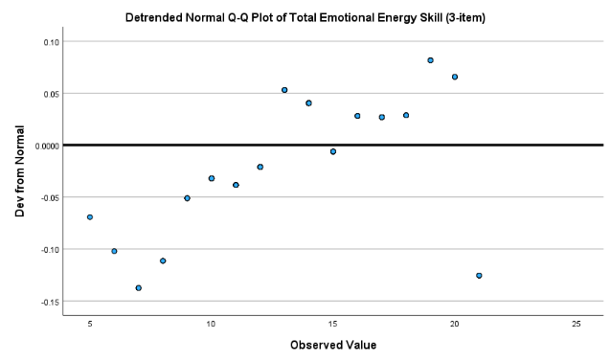 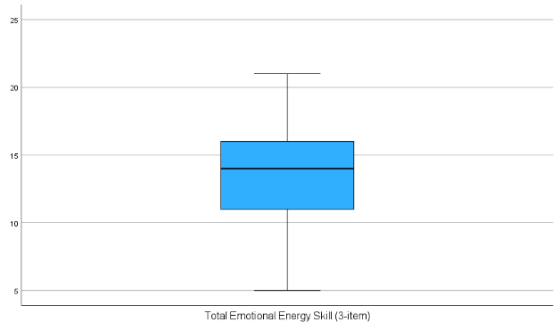

***ANALYSIS:*** *The difference between the 5% trimmed mean, which eliminates the top and bottom 5% of observations, and* ***the mean is –0.04****. The* ***box and whiskers plot shows no circles or stars above and below the whiskers that indicate an outlier or an extreme****, though.* ***The kurtosis figures is negative at -0.347, indicating that the distribution is platykurtic – relatively flat distribution****.* ***The skewness is also negative at –0.128, indicating that the distribution is skewed to the left****. The* ***histogram and Q-Q plots show that the distribution is not normal****. Most importantly, though, the* ***K-S significance value is LOWER than the critical value of 0.05 at <0.001 = SIGNIFICANT RESULT = reject the null hypothesis = NOT NORMAL DISTRIBUTION****.*

***Thus, the individual scale “Total Emotional Energy” is not normally distributed.***

**Tests for Normality (Total Mental Energy – 3-items)**

Analyze > Descriptive Statistics > Explore > pick and choose variables (**TotMES3**) > Statistics > check Outliers > continue > Plots > check Normality Plots with Tests > continue > Options > check Exclude Cases Pairwise > continue > Check Both > Okay and look at histograms, box plots, mean, trimmed mean, etc.

 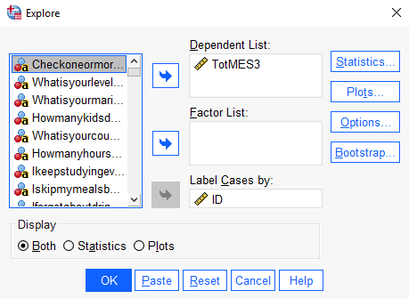

  

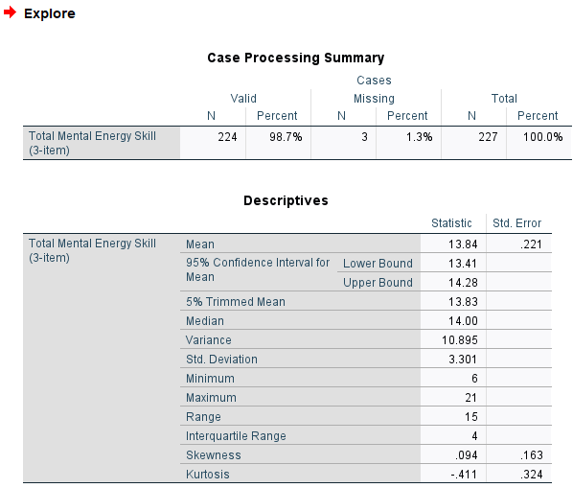 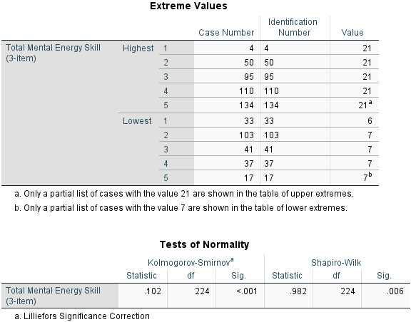

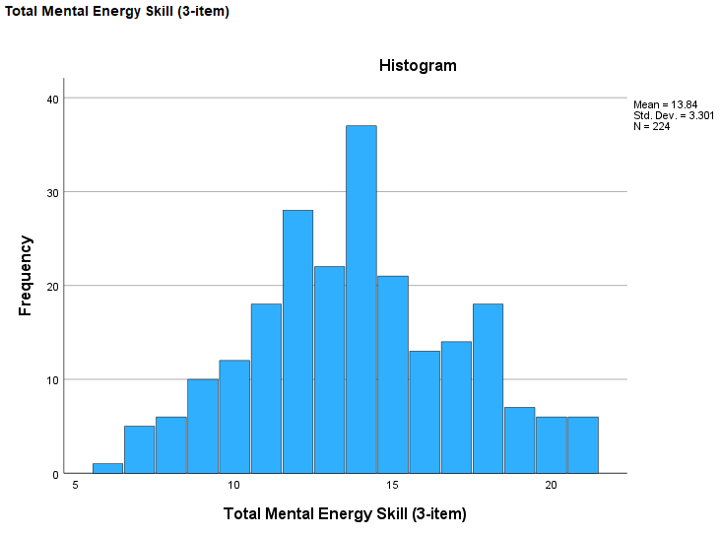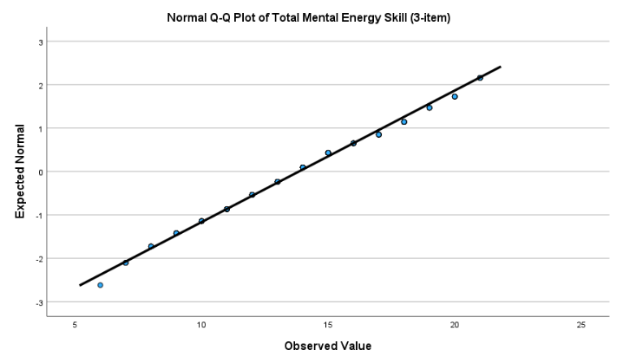 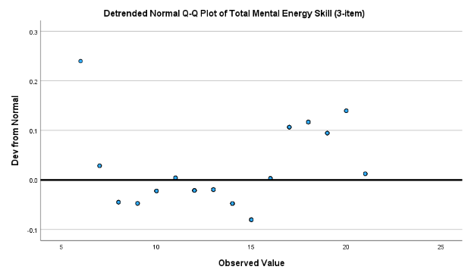 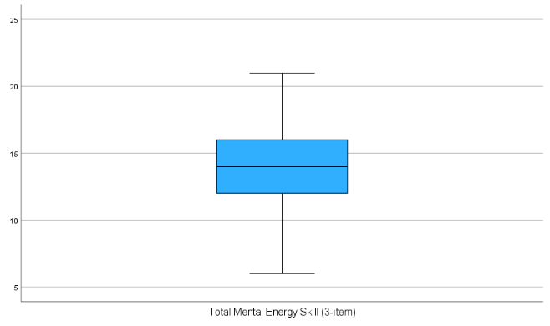

***ANALYSIS:*** *The difference between the 5% trimmed mean, which eliminates the top and bottom 5% of observations, and the* ***mean is not large at only +0.01****. This means that there are* ***no outliers and extreme values*** *that dragged the mean either upward or downward. This is also seen in the* ***box and whiskers plot, where there are no circles or stars above and below the whiskers****.* ***The kurtosis figures is negative at -0.411, indicating that the distribution is platykurtic – relatively flat distribution****. The* ***skewness is positive at 0.094, indicating that the distribution is slightly skewed to the right****. The* ***histogram and Q-Q plots show that the distribution is not normal****. Most importantly, though, the* ***K-S significance value is LOWER than the critical value of 0.05 at <0.001 = SIGNIFICANT RESULT = reject the null hypothesis = NOT NORMAL DISTRIBUTION****.*

***Thus, the individual scale “Total Mental Energy” is not normally distributed****.*

**Tests for Normality (Total Spiritual Energy – 3-items)**

Analyze > Descriptive Statistics > Explore > pick and choose variables (**TotSES3**) > Statistics > check Outliers > continue > Plots > check Normality Plots with Tests > continue > Options > check Exclude Cases Pairwise > continue > Check Both > Okay and look at histograms, box plots, mean, trimmed mean, etc.

 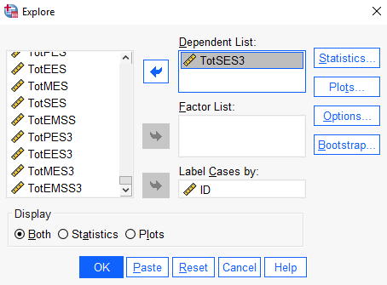

  

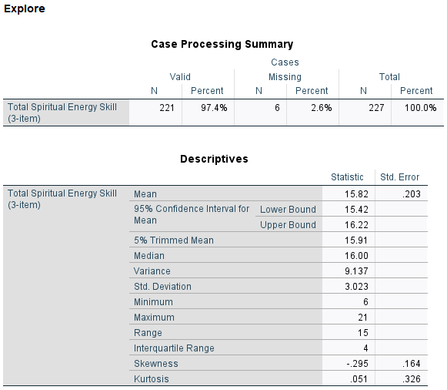 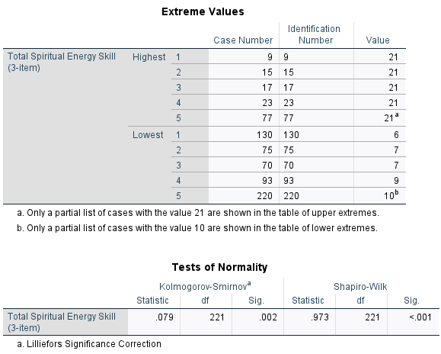

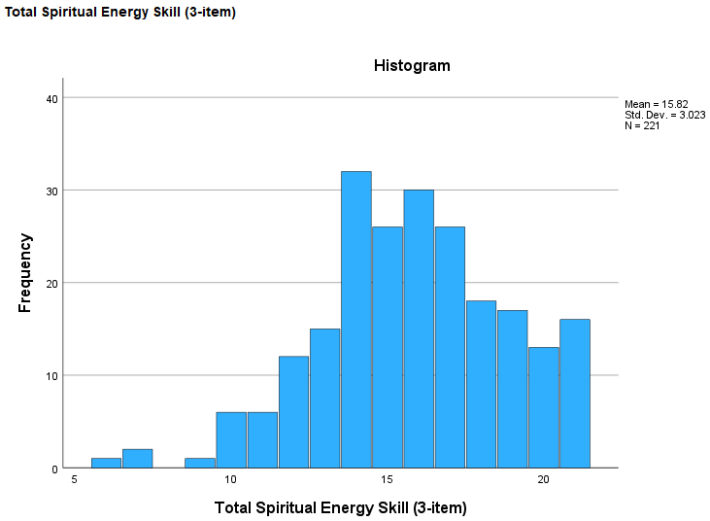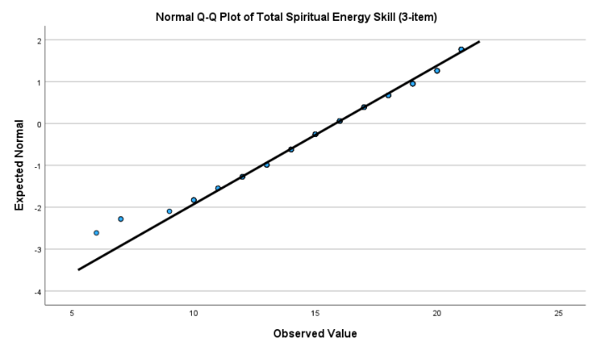

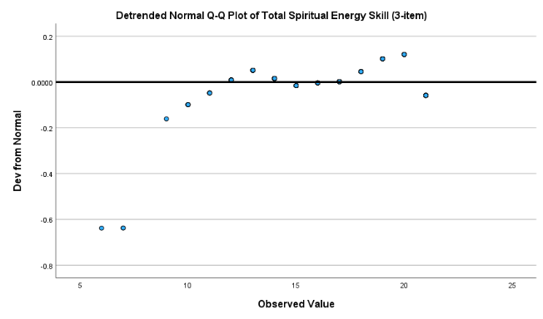 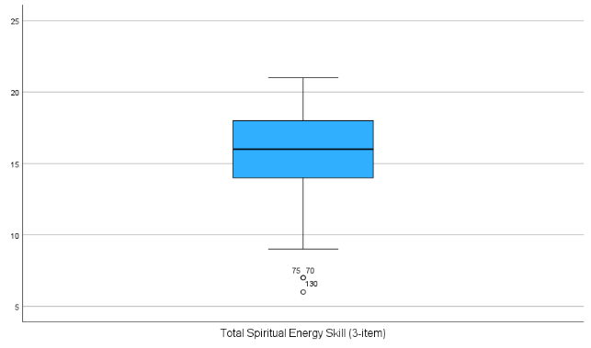

***ANALYSIS:*** *The difference between the 5% trimmed mean, which eliminates the top and bottom 5% of observations, and* ***the mean is +.09****. This means that* ***there are some outliers or extreme values*** *that dragged the mean downward. This is also seen in* ***the box and whiskers plot****, where* ***there are 3 circles (ID number 70, 75, and 130) below the whiskers****.* ***The kurtosis figures is positive at +0.051, indicating that the distribution is leptokurtic – relatively peaked distribution****. The* ***skewness is negative at -0.295, indicating that the distribution is skewed to the left****. The* ***histogram and Q-Q plots show that the distribution is not normal*** *– with a more distinct skew to the left compared to plots in other individual scales. Most importantly, though, the* ***K-S significance value is LOWER than the critical value of 0.05 at <0.002 = SIGNIFICANT RESULT = reject the null hypothesis = NOT NORMAL DISTRIBUTION****.*

***Thus, the individual scale “Total Spiritual Energy” is not normally distributed.***

**Tests for Normality (Total Summated Energy – 3-items)**

Analyze > Descriptive Statistics > Explore > pick and choose variables (**TotEMSS3**) > Statistics > check Outliers > continue > Plots > check Normality Plots with Tests > continue > Options > check Exclude Cases Pairwise > continue > Check Both > Okay and look at histograms, box plots, mean, trimmed mean, etc.

 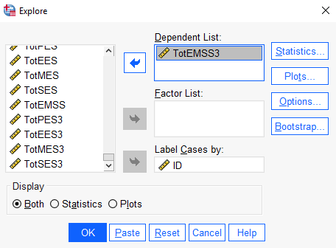

  

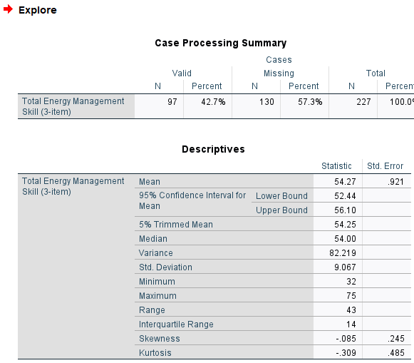 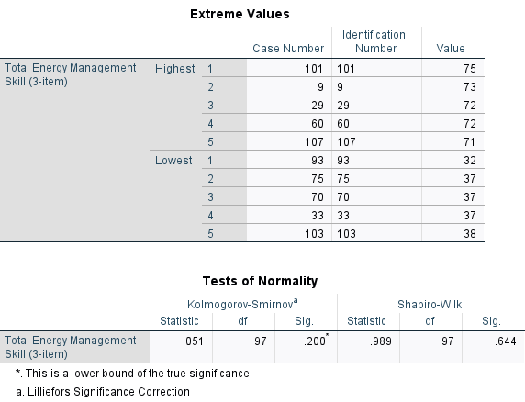

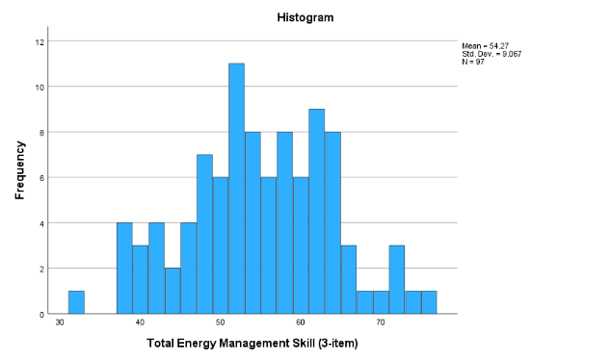 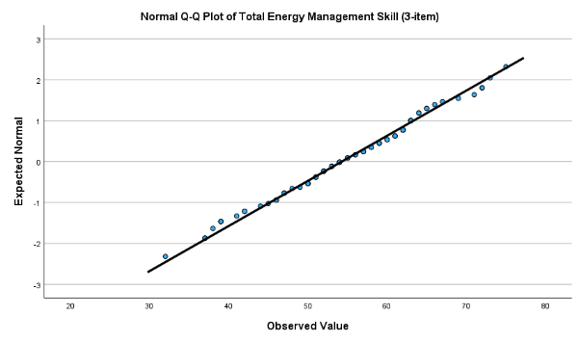

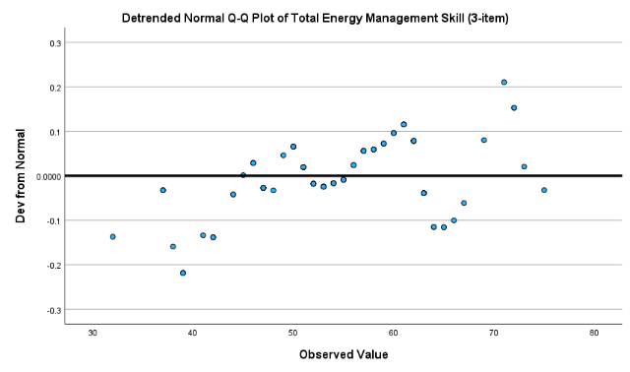 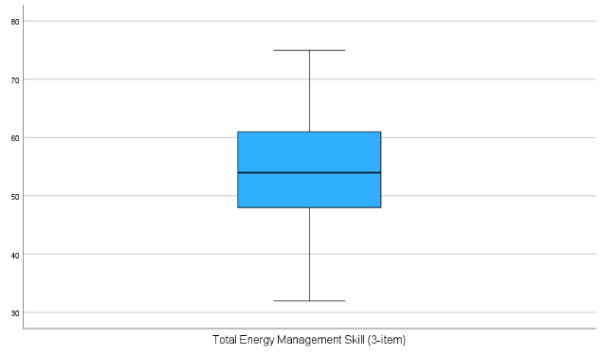

***ANALYSIS:*** *The difference between the 5% trimmed mean, which eliminates the top and bottom 5% of observations, and* ***the mean is not large at only +0.02****. This means that there are* ***no outliers and extreme values*** *that dragged the mean either upward or downward. This is also seen in the* ***box and whiskers plot, where there are no circles or stars above and below the whiskers****.* ***The kurtosis figures is negative at -0.309, indicating that the distribution is platykurtic – relatively flat distribution****. The* ***skewness is negative at -0.085, indicating that the distribution is slightly skewed to the left****. The* ***histogram shows that the distribution looks like a normal distribution****. Most importantly, though, the* ***K-S significance value is HIGHER than the critical value of 0.05 at 0.200 = INSIGNIFICANT RESULT = do not reject the null hypothesis = NORMAL DISTRIBUTION.***

***Thus, the individual scale “Total Energy Management” is normally distributed.***

# **STEP 8: ADD THE SCORES + CREATE THE INDIVIDUAL AVERAGED SUMMATED SCALES AND TOTAL AVERAGED SUMMATED ENERGY MANAGEMENT SKILLS SCALE**

*Based on the variables computed and created for* ***STEPS 5-7****, we now compute and create averaged scales.*

**Averaged Physical Energy**

Transform > Compute Variable > under “target variable”, type new variable (**AvePES3**) > click on the “type and label” button > fill in label (“**Averaged Physical Energy Skill (3-item)**”) > continue > add all variables (items based on sample 1 that is classified as Physical Energy – **TotPES3 / 3**) > Okay > Update codebook.

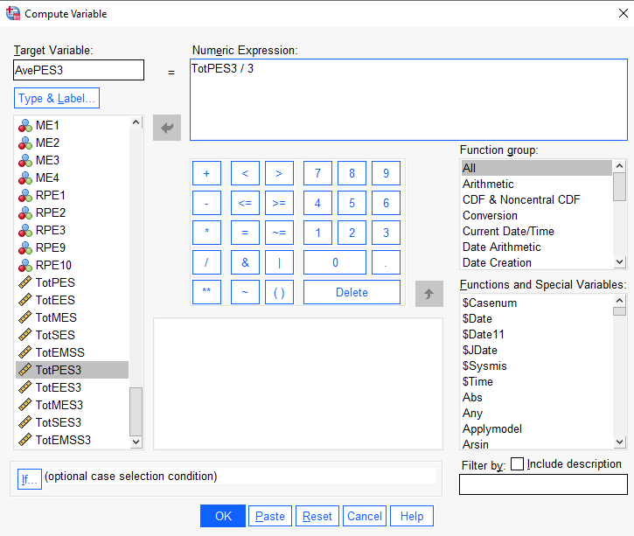

**Averaged Emotional Energy**

Transform > Compute Variable > under “target variable”, type new variable (**AveEES3**) > click on the “type and label” button > fill in label (“**Averaged Emotional Energy Skill (3-item)**”) > continue > add all variables (items based on sample 1 that is classified as Emotional Energy – **TotEES3 / 3**) > Okay > Update codebook.

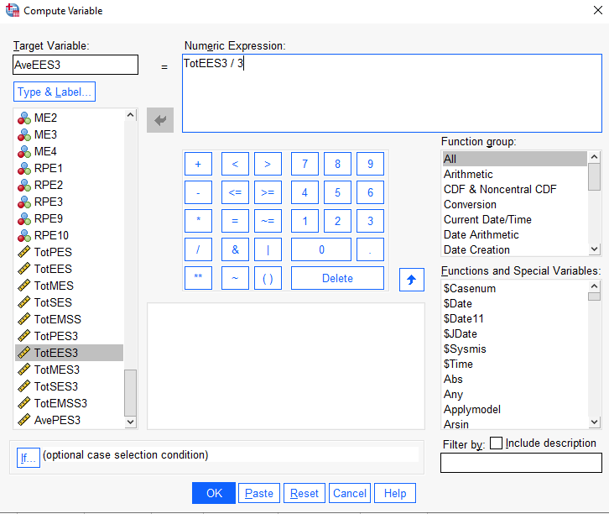

**Averaged Mental Energy**

Transform > Compute Variable > under “target variable”, type new variable (**AveMES3**) > click on the “type and label” button > fill in label (“**Averaged Mental Energy Skill (3-item)**”) > continue > add all variables (items based on sample 1 that is classified as Mental Energy – **TotMES3 / 3**) > Okay > Update codebook.

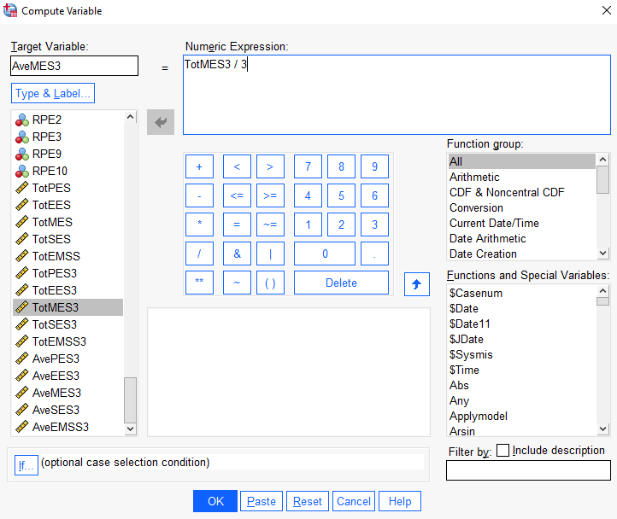

**Averaged Spiritual Energy**

Transform > Compute Variable > under “target variable”, type new variable **AveSES3**) > click on the “type and label” button > fill in label (“**Averaged Spiritual Energy Skill (3-item)**”) > continue > add all variables (items based on sample 1 that is classified as Mental Energy – **TotSES3 / 3**) > Okay > Update codebook.

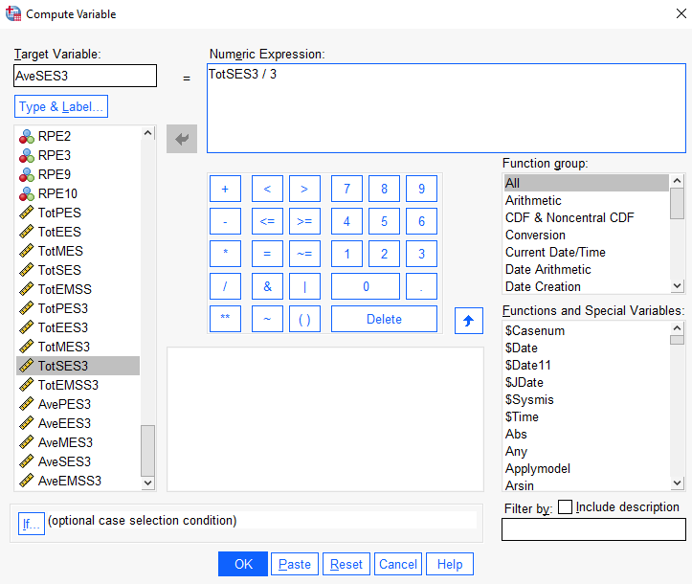

**Total Averaged Summated Energy**

Transform > Compute Variable > under “target variable”, type new variable (**AveEMSS3**) > click on the “type and label” button > fill in label (“**Averaged Total Energy Management Skill (3-item)**”) > continue > add all variables (Total summated of the averaged energy skills above – **AvePES3 + AveEES3 + AveMES3 + AveSES3 / 4**) > Okay > Update codebook.

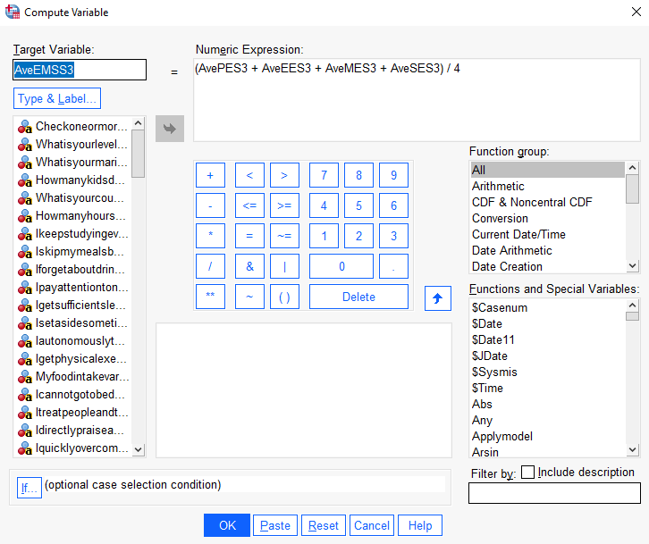

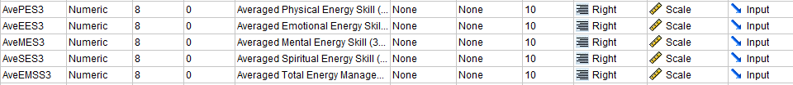

# **STEP 9: CONDUCT RELIABILITY ANALYSIS FOR EACH OF THE SCALE**

*In the previous step, we have created the average of total scores (3-items) for each energy management skills and the total summated energy scales. Now we need to do Reliability Analysis for each averaged energy skill and averaged total summated scales.*

**Tests for Reliability of Scale (Total Averaged Summated Energy – 3-items)**

Analyze > scale > reliability analysis > select variables (**AvePES3, AveEES3, AveMES3, AveSES3**) to “item” > in “model”, select “alpha” > enter scale label > statistics > under “descriptives for”, select “scale” and “scale if item deleted” > under “summaries” and “inter item”, select “correlation” > continue > okay

 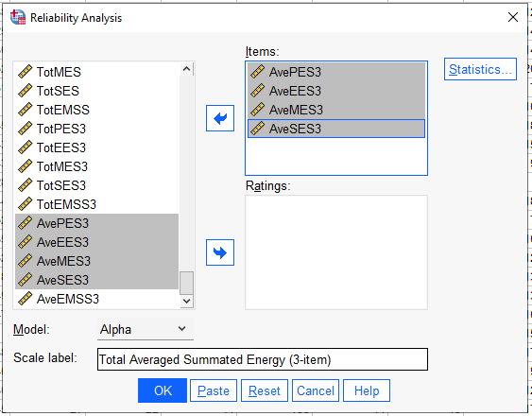 

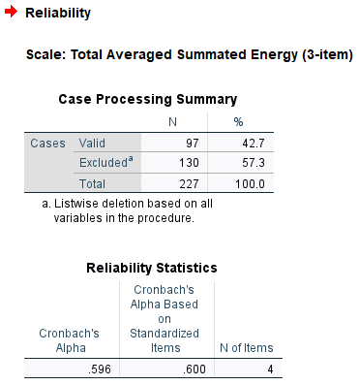

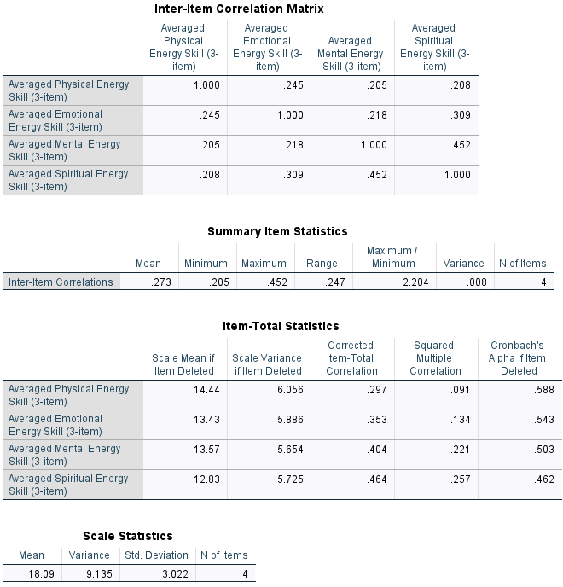

***ANALYSIS:*** *The acceptable figure for Cronbach’s Alpha, which shows whether items in the scale measure the same construct, is .7 and above. The acceptable figure for the mean inter-item correlation is acceptable between .2 to .4. The acceptable figure for corrected total item correlation is .3 and above.*

***Cronbach’s Alpha for the Total Averaged Summated Energy scale is not acceptable at .596****. Just like with the 3 item individual scales in STEPS 5-7, the* ***low Cronbach’s Alpha figure is most likely due to the number of items in this summated scale being less than 10****. The* ***mean inter-item correlation is however acceptable at .273****. It can be seen that 3 out of the 4 corrected item-total correlations are above .3.*

# **STEP 10: CONDUCT TESTS FOR NORMALITY FOR EACH AVERAGED SCORE**

**Tests for Normality (Averaged Physical Energy – 3-items)**

Analyze > Descriptive Statistics > Explore > pick and choose variables (**AvePES3**) > Statistics > check Outliers > continue > Plots > check Normality Plots with Tests > continue > Options > check Exclude Cases Pairwise > continue > Check Both > Okay and look at histograms, box plots, mean, trimmed mean, etc.

 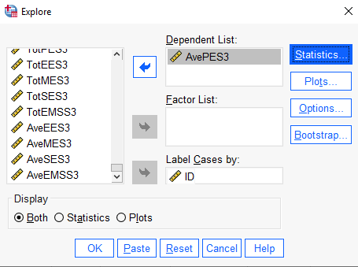

  

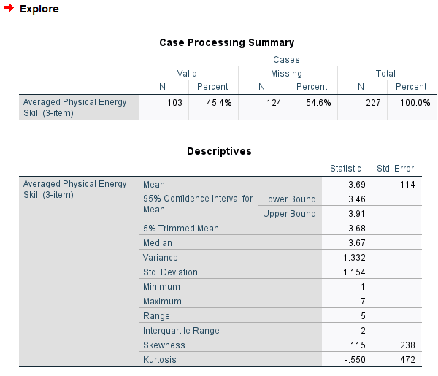 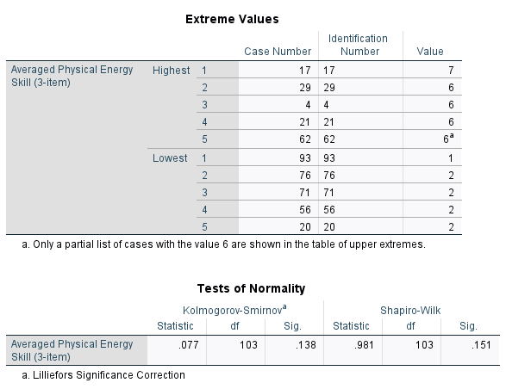

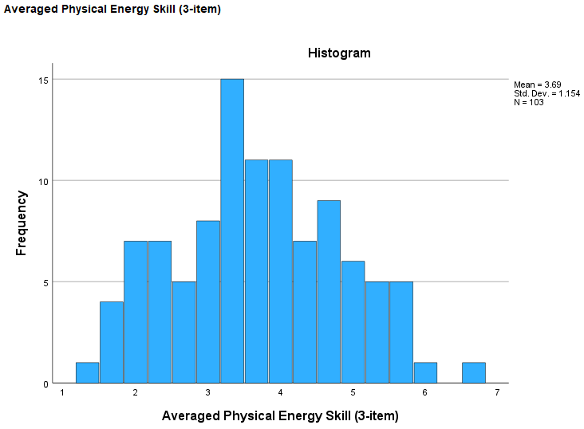 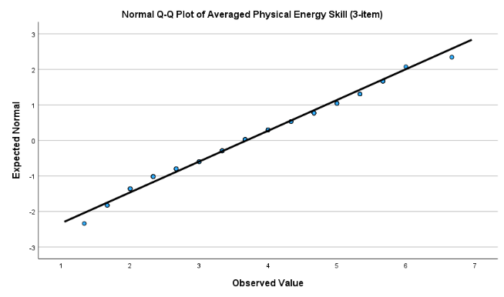 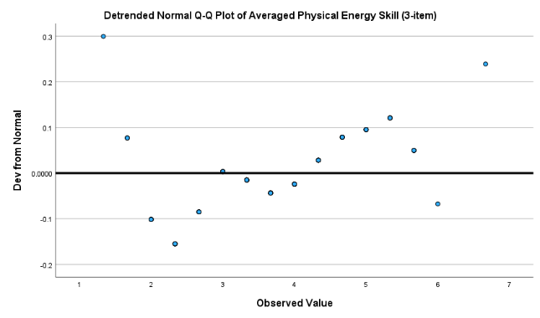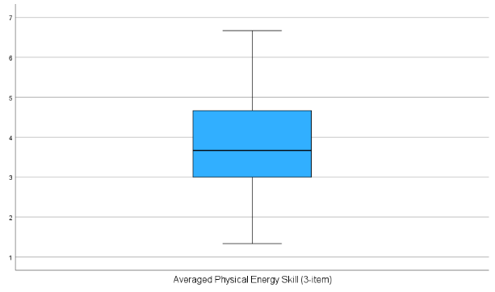

***ANALYSIS:*** *The difference between the 5% trimmed mean, which eliminates the top and bottom 5% of observations, and* ***the mean is not large at +0.01****. This means that* ***there are no outliers and extreme values*** *that dragged the mean either upward or downward. This is also seen in the* ***box and whiskers plot, where there are no circles (outliers) or stars (extremes)*** *above and below the whiskers.* ***The kurtosis figure is negative at -0.550, indicating that the distribution is platykurtic – relatively flat distribution****. The* ***skewness is also positive at 0.115, indicating that the distribution is skewed to the right****. The* ***histogram shows that the distribution is slightly skewed to the right****. On the other hand,* ***the K-S significance value is HIGHER than the critical value of 0.05 at 0.138 = INSIGNIFICANT RESULT = do not reject the null hypothesis = NORMAL DISTRIBUTION.***

***Thus, the individual scale “Averaged Physical Energy” is normally distributed.***

**Tests for Normality (Averaged Emotional Energy – 3-items)**

Analyze > Descriptive Statistics > Explore > pick and choose variables (**AveEES3**) > Statistics > check Outliers > continue > Plots > check Normality Plots with Tests > continue > Options > check Exclude Cases Pairwise > continue > Check Both > Okay and look at histograms, box plots, mean, trimmed mean, etc.

 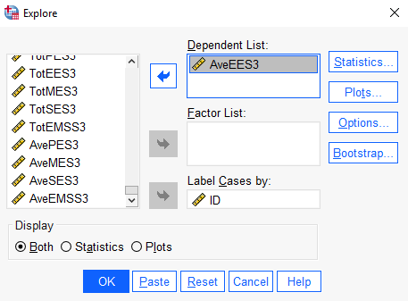

  

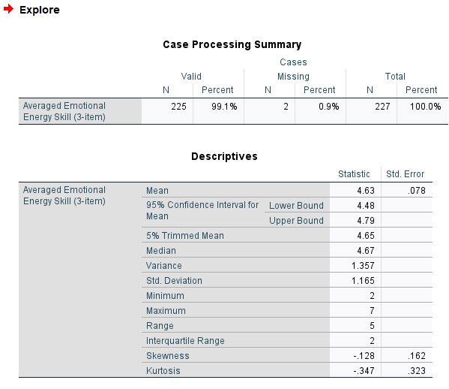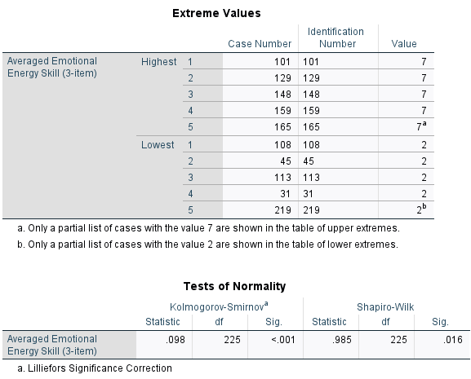

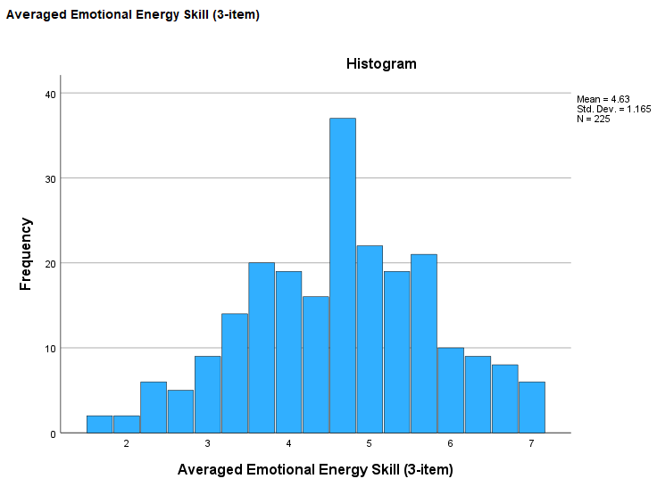 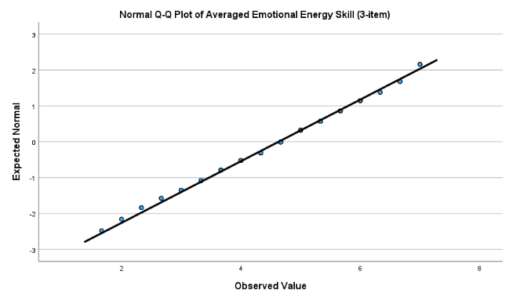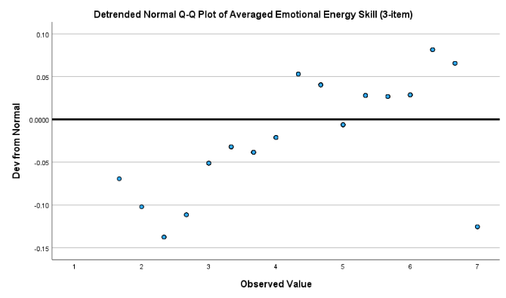 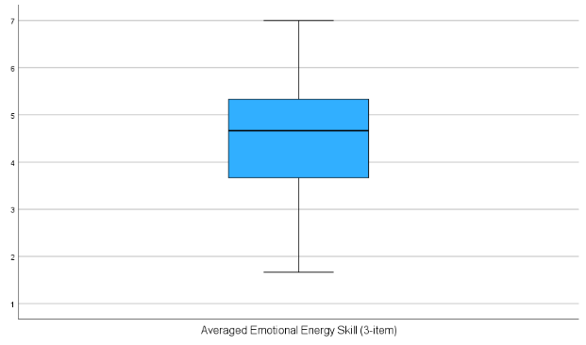

***ANALYSIS:*** *The difference between the 5% trimmed mean, which eliminates the top and bottom 5% of observations, and* ***the mean is not large –0.02.*** *This means that* ***there are no outliers and extreme values*** *that dragged the mean either upward or downward. This is also seen in the* ***box and whiskers plot, where there are no circles or stars above and below the whiskers****. The* ***kurtosis figures is negative at -0.347, indicating that the distribution is platykurtic – relatively flat distribution****. The* ***skewness is also negative at –0.128, indicating that the distribution is skewed to the left.*** *The* ***histogram and Q-Q plots show that the distribution is not normal****. Most importantly, though, the* ***K-S significance value is LOWER than the critical value of 0.05 at <0.001 = SIGNIFICANT RESULT = reject the null hypothesis = NOT NORMAL DISTRIBUTION.***

***Thus, the individual scale “Averaged Emotional Energy” is not normally distributed.***

**Tests for Normality (Averaged Mental Energy – 3-items)**

Analyze > Descriptive Statistics > Explore > pick and choose variables (**AveMES3**) > Statistics > check Outliers > continue > Plots > check Normality Plots with Tests > continue > Options > check Exclude Cases Pairwise > continue > Check Both > Okay and look at histograms, box plots, mean, trimmed mean, etc.

 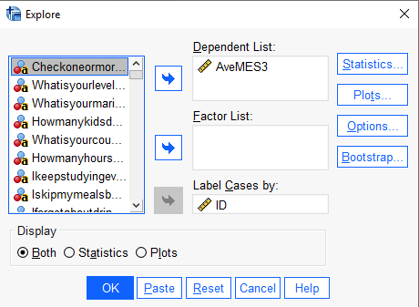

  

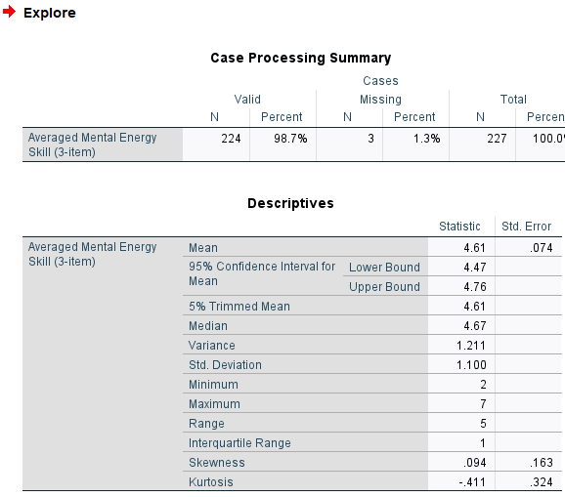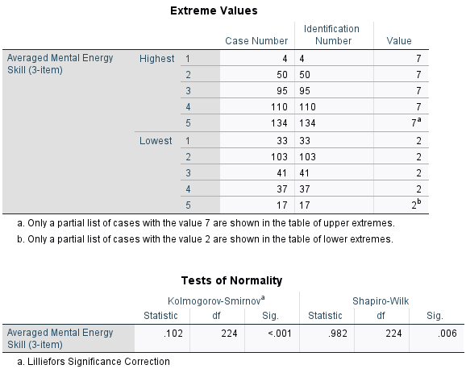

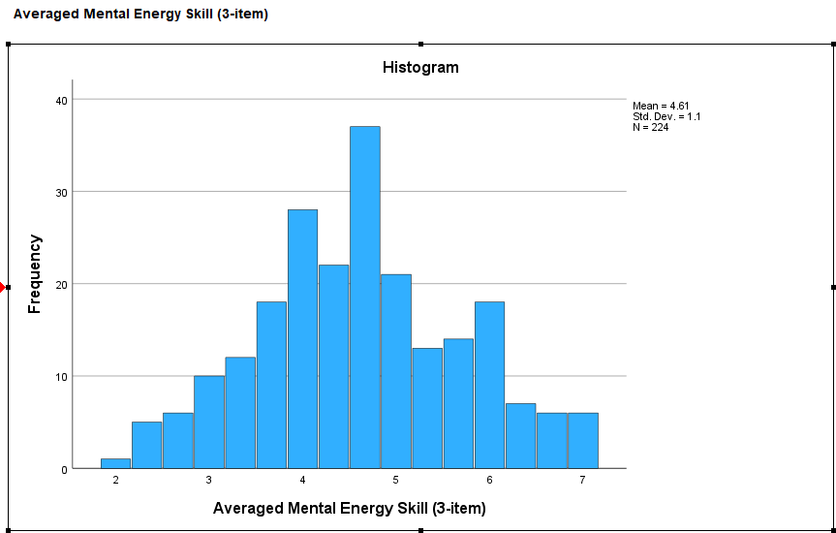 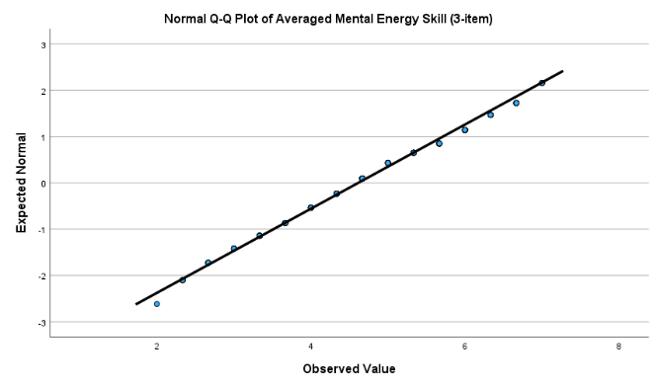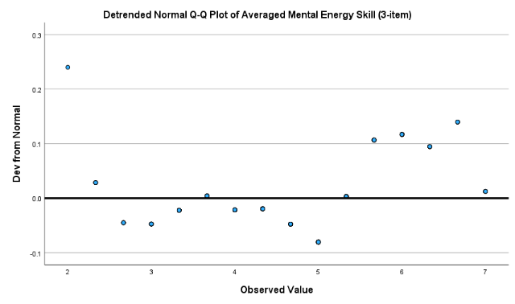 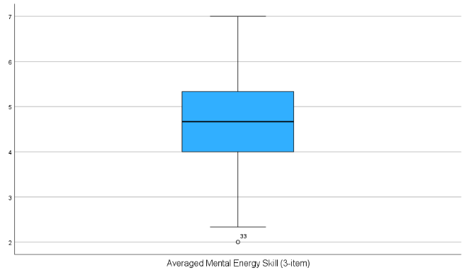

***ANALYSIS:*** *There is no difference between the 5% trimmed mean, which eliminates the top and bottom 5% of observations, and the mean. This means that* ***there are no outliers and extreme values*** *that dragged the mean either upward or downward. However, the* ***box and whiskers plot show that there is one circle (ID no 33) below the lower whisker, indicating an outlier****. The* ***kurtosis figures is negative at -0.411, indicating that the distribution is platykurtic – relatively flat distribution****. The* ***skewness is positive at 0.094, indicating that the distribution is slightly skewed to the right.*** *The* ***histogram and Q-Q plots show that the distribution is not normal****. Most importantly, though, the* ***K-S significance value is LOWER than the critical value of 0.05 at <0.001 = SIGNIFICANT RESULT = reject the null hypothesis = NOT NORMAL DISTRIBUTION.***

***Thus, the individual scale “Averaged Mental Energy” is not normally distributed.***

**Tests for Normality (Averaged Spiritual Energy – 3-items)**

Analyze > Descriptive Statistics > Explore > pick and choose variables (**AveSES3**) > Statistics > check Outliers > continue > Plots > check Normality Plots with Tests > continue > Options > check Exclude Cases Pairwise > continue > Check Both > Okay and look at histograms, box plots, mean, trimmed mean, etc.

 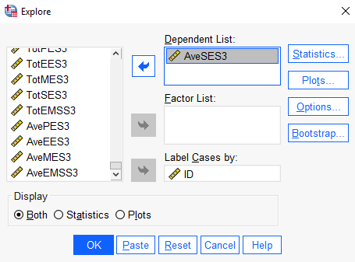

  

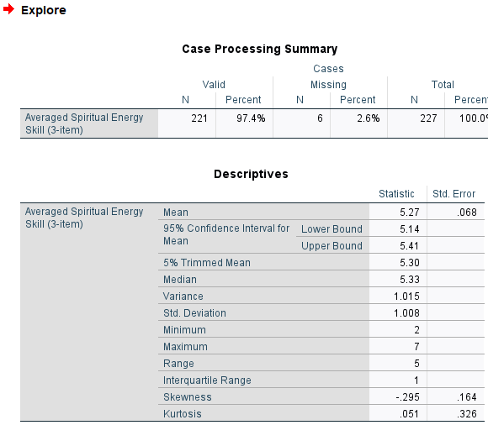 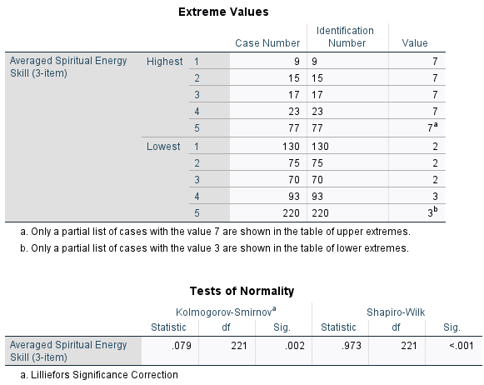

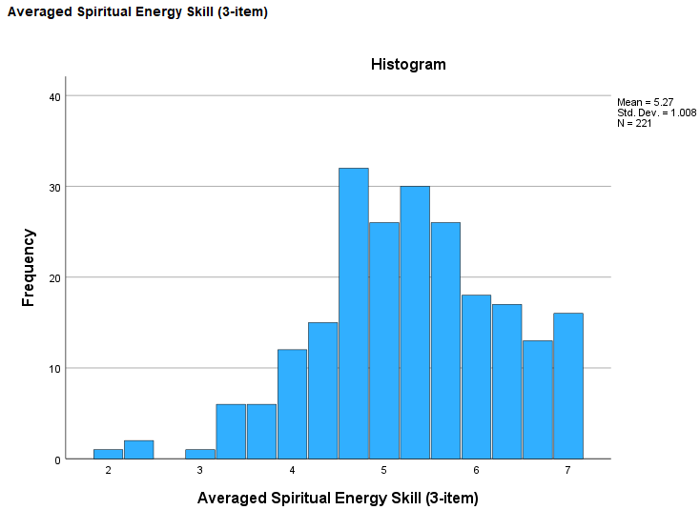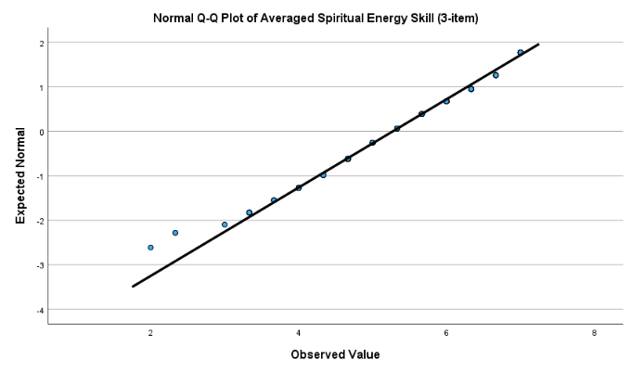

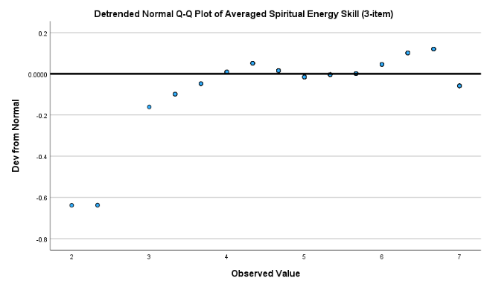 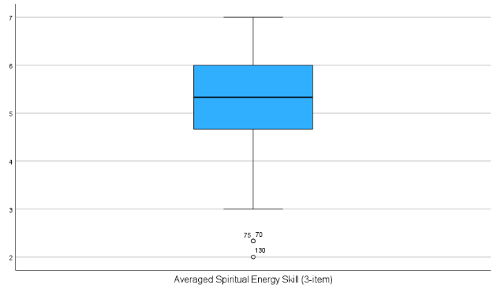

***ANALYSIS:*** *The difference between the 5% trimmed mean, which eliminates the top and bottom 5% of observations, and* ***the mean is -0.03****. The* ***box and whiskers plot, shows 3 circles (ID number 70, 75, and 130) below the lower whisker****. The* ***kurtosis figure is positive at +0.051, indicating that the distribution is leptokurtic – relatively peaked distribution****. The* ***skewness is negative at -0.295, indicating that the distribution is skewed to the left****. The* ***histogram and Q-Q plots show that the distribution is not normal*** *– with a more distinct skew to the left compared to plots in other individual scales. Most importantly, though, the* ***K-S significance value is LOWER than the critical value of 0.05 at 0.002 = SIGNIFICANT RESULT = reject the null hypothesis = NOT NORMAL DISTRIBUTION.***

***Thus, the individual scale “Averaged Spiritual Energy” is not normally distributed.***

**Tests for Normality (Total Averaged Summated Energy – 3-items)**

Analyze > Descriptive Statistics > Explore > pick and choose variables (**AveEMSS3**) > Statistics > check Outliers > continue > Plots > check Normality Plots with Tests > continue > Options > check Exclude Cases Pairwise > continue > Check Both > Okay and look at histograms, box plots, mean, trimmed mean, etc.

 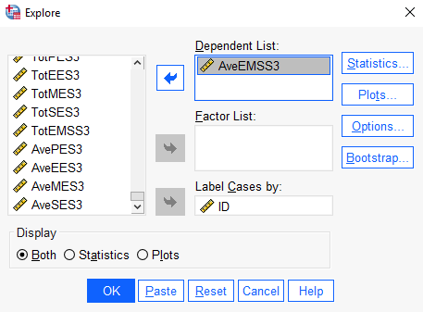

  

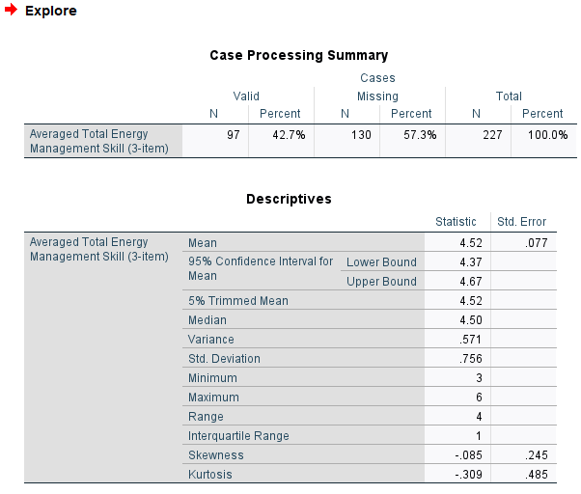 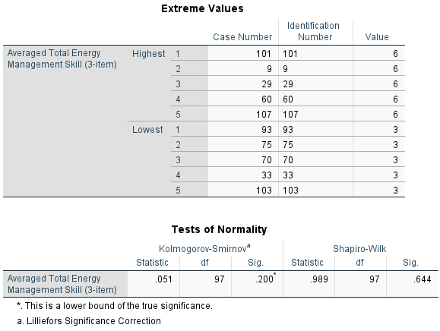

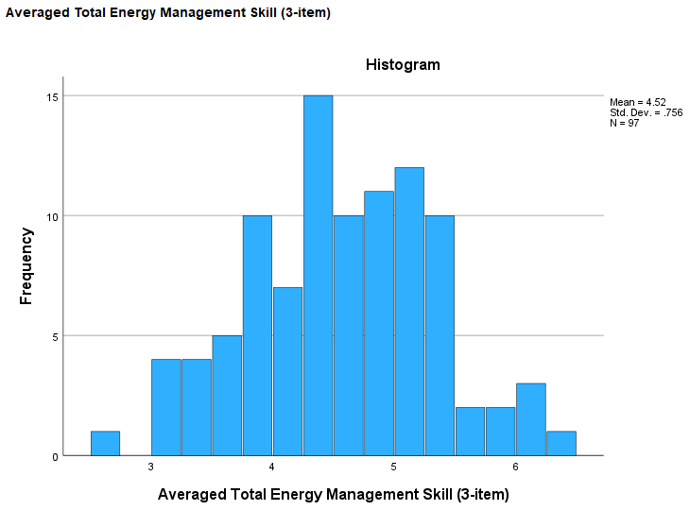 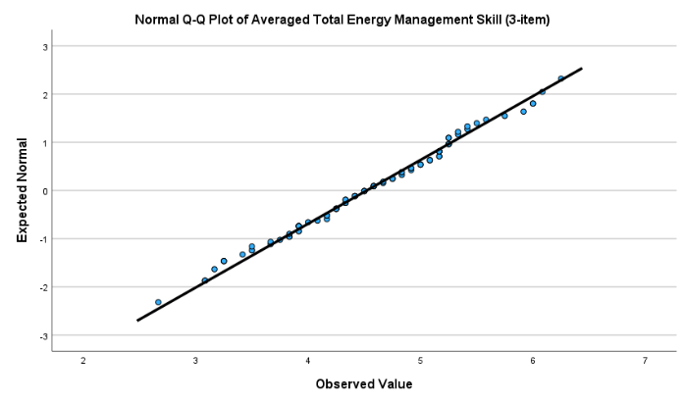

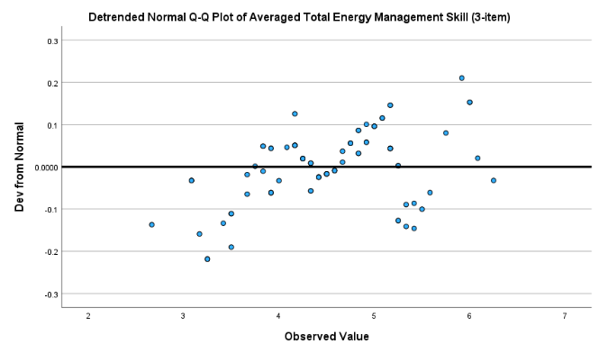 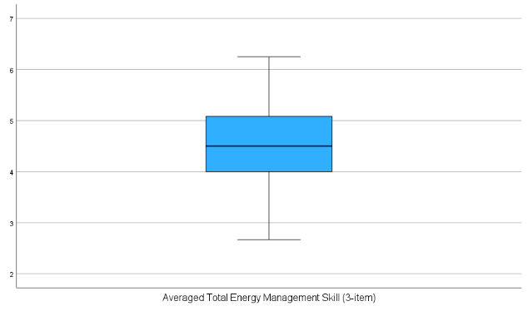

***ANALYSIS:*** *There is no difference between the 5% trimmed mean, which eliminates the top and bottom 5% of observations, and the mean. This means that there are* ***no outliers and extreme values*** *that dragged the mean either upward or downward. This is also seen in the* ***box and whiskers plot, where there are no circles or stars above and below the whiskers****.* ***The kurtosis figure is negative at -0.309, indicating that the distribution is platykurtic – relatively flat distribution****. The* ***skewness is negative at -0.085, indicating that the distribution is slightly skewed to the left****. The* ***histogram shows that the distribution looks like a normal distribution****. Most importantly, though, the* ***K-S significance value is HIGHER than the critical value of 0.05 at 0.200 = INSIGNIFICANT RESULT = do not reject the null hypothesis = NORMAL DISTRIBUTION.***

***Thus, the individual scale “Total Averaged Energy Management” is normally distributed.***

# **STEP 11: SUMMARY, CONCLUSIONS, & COMPARISON OF RELIABILITY RESULTS**

The summarized results for the reliability and normality tests are shown in the table below:

|  |  |  |  |  |  |  |  |  |
| --- | --- | --- | --- | --- | --- | --- | --- | --- |
|  | **Tests for Reliability** | | | **Tests for Normality** | | | | |
|  | **Cronbach’s Alpha** | **Mean Inter-item Correlation** | **Number of Corrected Total-Item Correlation above .3** | **Kolmogorov-Smirnov values** | **Difference between 5% trimmed mean and mean** | **Number of outliers as per the box and whiskers** | **Skewness value** | **Kurtosis value** |
| **ALL ITEMS (Step 3)** | **.750** |  |  |  |  |  |  |  |
| **ALL ITEMS (Step 4)** | **.824** | - | 18/26 | - | - | - | - | - |
| **TotPES3 - Total Physical Energy Skill (3-item)** | .483 | **.237** | 2/3 | **.138** | **.03** | **0** | .115 | -.550 |
| **TotEES3 - Total Emotional Energy Skill (3-item)** | .663 | **.394** | 3/3 | <.001 | -.04 | **0** | -.128 | -.347 |
| **TotMES3 - Total Mental Energy Skill (3-item)** | .587 | **.321** | 3/3 | <.001 | **.01** | **0** | .094 | -.411 |
| **TotSES3 - Total Spiritual Energy Skill (3-item)** | .561 | **.302** | 3/3 | <.002 | .09 | 3 | -.295 | .051 |
| **TotEMSS3 - Total Energy Management Skill (3-item)** | **.729** | .186 | 9/12 | **.200** | **.02** | **0** | **-.085** | -.309 |
| **AvePES3- Averaged Physical Energy Skill (3-item)** | - | - | - | **.138** | **.01** | **0** | .115 | -.550 |
| **AveEES3- Averaged Emotional Energy Skill (3-item)** | - | - | - | <.001 | **-.02** | **0** | -.128 | -.347 |
| **AveMES3- Averaged Mental Energy Skill (3-item)** | - | - | - | <.001 | **0** | 1 | .094 | -.411 |
| **AveSES3- Averaged Spiritual Energy Skill (3-item)** | - | - | - | .002 | **-.03** | 3 | -.295 | .051 |
| **AveEMSS3- Averaged Total Energy Management Skill (3-item)** | .596 | **.273** | 3/4 | **.200** | **0** | **0** | **-.085** | -.309 |

A comparison table between these results and the findings of Zhang, Tong, Huo (2018) is seen below:

|  |  |  |  |  |  |  |
| --- | --- | --- | --- | --- | --- | --- |
| **Comparison: Cronbach’s Alpha Value** | | | | | | |
|  | **Ours** | **Zhang, Tong, Huo (2018)** | | | | |
|  | **Total** | **Sample 1** | **Sample 2** | **Sample 3** | **Sample 4** | **Averaged Samples 1-4** |
| **Physical** | .483 | **.72** | **.70** | **.70** | .63 | .69 |
| **Emotional** | .663 | **.79** | **.83** | **.70** | **.74** | **.77** |
| **Mental** | .587 | **.79** | **.75** | .67 | .69 | **.73** |
| **Spiritual** | .561 | .64 | **.73** | .58 | **.71** | .67 |
| **TOTAL** | **.729** | - |  |  |  |  |
| **AVERAGED TOTAL** | .596 |  |  |  |  | **.71** |

***Test for Normality***

The normality tests show that the Kolmogorov-Smirnov (K-S) values for the Physical Energy Skill scales, Total Management Energy Skill scale, and the Averaged Total Energy Management Skill scale are higher than the critical value of 0.05. This means that there is an extremely high probability that we will make a mistake if we reject the null hypothesis of normality, and thus, we do not reject it (Korchagina, 2023). This indicates that the distribution is normal for these 3 scales. On the other hand, all other individual energy scales have K-S values lower than the critical value of 0.05. This means that there is an extremely low chance that we will make a mistake if we reject the null hypothesis of normality, and thus, we reject it (Korchagina, 2023). This indicates that the distribution is not normal for the other scales.

Other than the K-S, we also check the difference between the 5% trimmed mean and the mean, the box and whiskers plot, the histogram, and the skewness and kurtosis values. We find that most scales have a small difference between their 5% trimmed mean and mean, have no outliers and extremes, are negatively skewed, and have platykurtic (flat) distributions.

***Test for Reliability***

The preliminary reliability tests conducted for all items/questions before reversal (as in Step 3) and right after reversal of negatively worded questions (as in Step 4) show Cronbach’s Alpha figures that are high at .750 and .824, respectively. This tells us that there is internal consistency – all items/questions in the scale measure the same construct - in the overall 26 item/question scale.

Following the exact 3 items/questions included by Zhang, Tong, & Huo (2018) in the individual scales of their reliability analysis, we get Cronbach’s Alpha values that are significantly lower and below the acceptable threshold of .7. The mean inter-item correlations for these individual scales, however, are within the acceptable range of between .2 and .4. Thus, we use the mean inter-item correlation figures for these individual scales instead of the Cronbach’s Alpha.

When we do the same reliability process for the Total Management Energy Skill scale, where we add all 3 items/questions per individual scale (physical, emotional, mental, and spiritual) for a total of 12 items/questions, we come up with an acceptable Cronbach’s Alpha value of .729.

In comparison to Zhang, Tong, & Huo (2018)’s reliability results, our Cronbach’s Alpha values are also generally lower than their individual scales and their total averaged scale.

We attribute these lower Cronbach’s Alpha values to two factors:

1.) The number of items/questions within our individual scales are just 3. Cronbach’s Alpha values in scales that contain less than 10 items/questions tend to be lower than scales that contain more than 10 items/questions (Korchagina, 2023). It is for this same reason why we obtained an acceptable Cronbach’s Alpha value for the Total Management Energy Skill scale (a 12 item/question scale).

2.) The quality of the responses of the respondents in our sample, which in this assignment, are students of the Data Analytics Tools class, may also be suspect to the low Cronbach’s Alpha value per individual scale. Students were asked to answer the survey questions in a limited amount of time. Thus, their responses could have not been well thought of. Some students may also have not taken the task of responding to the survey questions seriously due to the unrelatedness of the survey questions (about psychology) to the course (Data Analysis Tools with the survey questions being given out at the first few minutes of the first class of the course). Finally, some students may have also not given out accurate responses due to privacy concerns, especially on some of the more personal questions in the survey.

Similar to our conclusions, Zhang, Tong, Huo (2018) also attributed their lower Cronbach’s Alpha scores for certain individual scales and certain samples on the small number of items for the samples per scale (only 3) and the maturity of the respondents in answering the survey questions (quality of responses). However, we suspect that these issues are more acute in our dataset for the reasons mentioned above.

# **STEP 12: ADDITIONAL ANALYSIS AND GRAPHS USING GROUPED VARIABLES**

We conduct additional analysis on the characteristics of our respondents (grouped variables we created at the very start of Step 4) to determine whether these impact their physical, emotional, mental, spiritual, and overall total energy management skills. As opposed to what we did in the previous required steps in this assignment, notably steps 5-10, where we exactly used Zhang, Tong, Huo (2018)’s 3-item/question for individual scales, we now use all items/questions in our survey. As we find in the last parts of Steps 3 and 4, Cronbach’s Alpha value for all items/questions in the overall scale is high at .750 without reversing negatively worded items/questions, and even higher at .824 using the reversed items/questions. Thus, we see no need to drop items/questions because are confident that all items/questions within the overall scale have good internal consistency – they generally measure the same construct.

***Energy Management Skills of Respondents Who Do Not Work and Who Work Varying Hours***

*Descriptives*

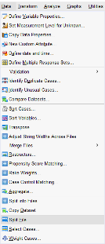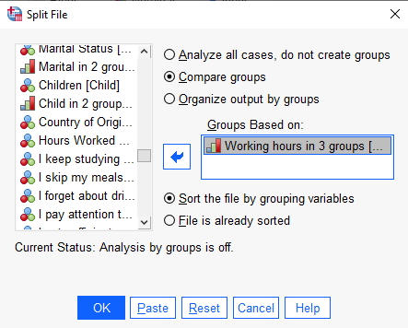 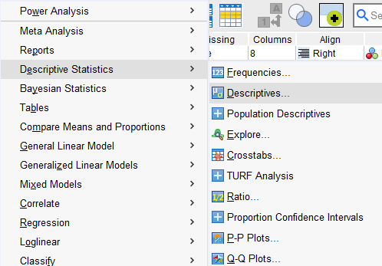 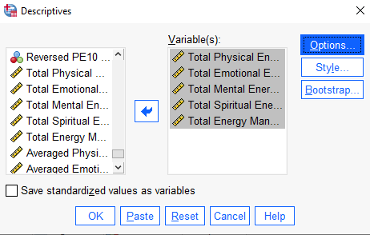

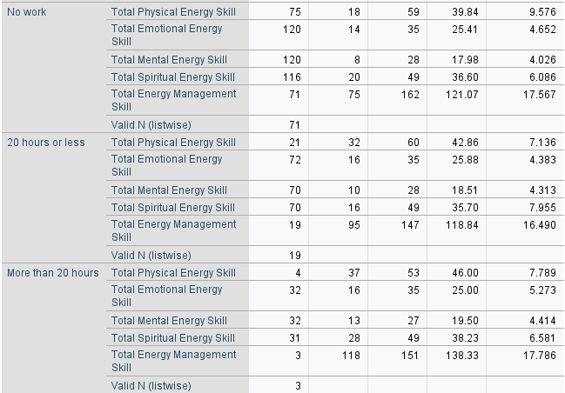

*Graph*

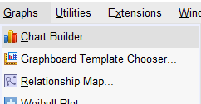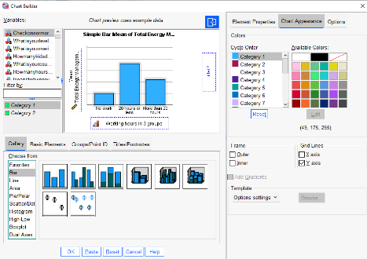

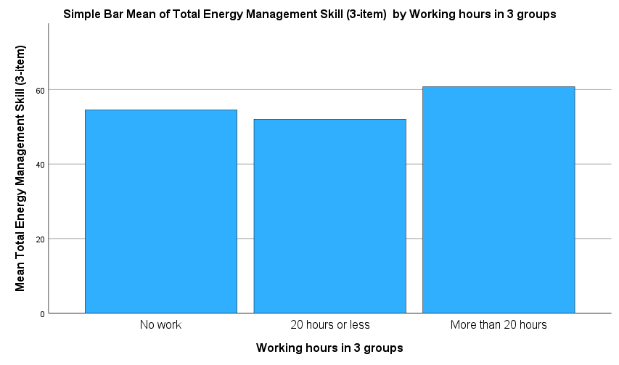

The survey shows that the 3 people who work more than 20 hours a week have the highest total energy managements skills with a mean score of 138.33. Far behind are people who don’t work (mean score of 121.07) and those who work 20 hours or less (mean of 118.84). Among the individual scales, the 3 people who work more than 20 hours a week has the highest mean scores for total physical energy skills, total mental energy skills, and total spiritual energy skills. On the other hand, the respondents who work more than 20 hours got the lowest score for total emotional energy skills, though the difference in scores for this subscale among the 3 groups are not wide (within 1 point).

***Total Energy Management Skills of Respondents Who Do Not Work and Who Work Varying Hours Per Gender***

*Graph*

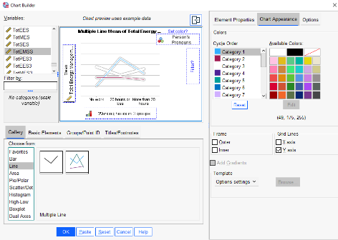

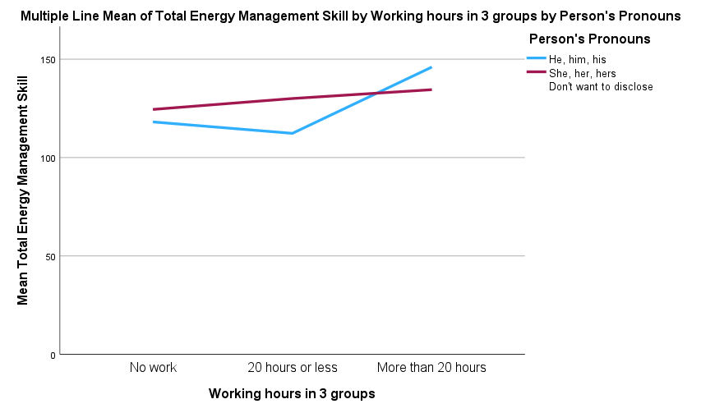

Additionally, we decompose working hours’ groups into gender. We find that women get a higher score for total energy management skills scores than men for respondents who do not work and who work 20 hours or less. However, for those working more than 20 hours, men’s total energy management skills scores were higher than women’s. Nonetheless, this shows that women have higher energy management skills for most of the respondents.

The high energy management skills scores for the 3 respondents who work more than 20 hours a week is possibly due to them being able to manage their time more efficiently given the limited number of hours they have to do other things outside of work. They likely allocate their extra time in things that would bring them more happiness and satisfaction, and thus, they get a higher energy score. They most likely have adapted to their work situations well, developing proper time and energy management skills to cope with their situation, and learning to have a decent work-life balance despite their higher working hours. Meanwhile, respondents who have more free time may have not used their time and energies as efficiently, with some of them getting less work done despite having more free time. For them, it may be the case of having a mindset that takes for granted the time that they have, choosing to delay tasks and work that could have been done earlier. This could leave them with a lower sense of accomplishment and achievement, and thus, lower energy management skills, than those who work more hours.

As for the differences in gender within work groups, it may be the case that women have more mature attitudes towards energy management than men. It is possible that they internalize/reflect more and strategize better how to best manage their time and energies than men.

***Energy Management Skills of Respondents Who Have and Do Not Have A Child***

*Descriptives*

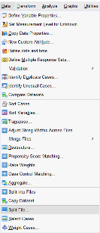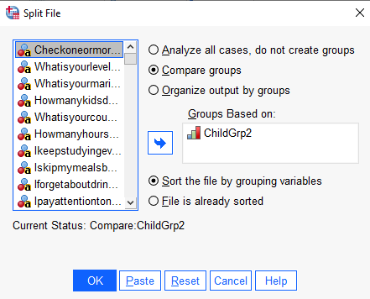

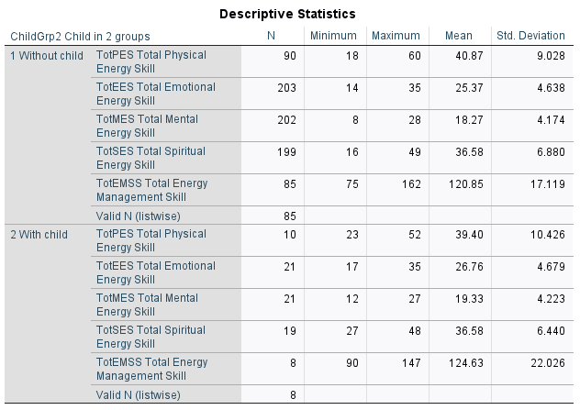

*Graph*

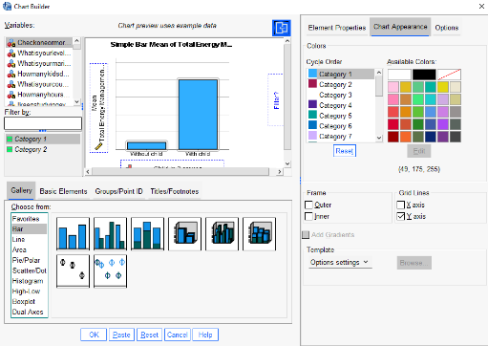

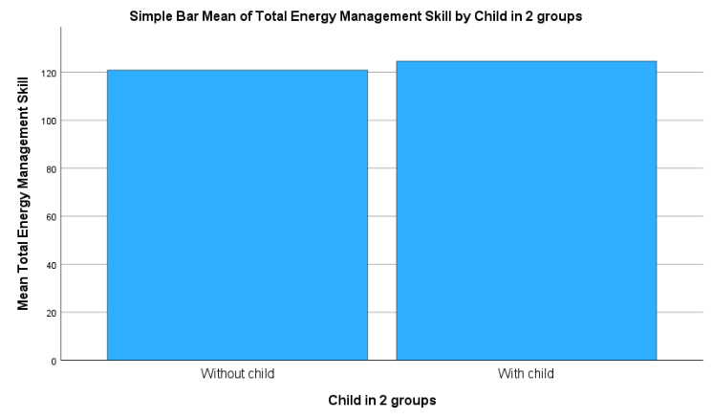

The survey shows that the 8 respondents who have children have the highest total energy managements skills score with a mean score of 124.63. About 4 points behind are the respondents who don’t have children (mean score of 120.85). Among the individual scales, the 8 respondents who have children have a mean score that is 1 point higher for total physical energy skills, total emotional energy skills, and total mental energy skills than respondents without children. Total spiritual energy skills are the same for those without and those with children.

***Energy Management Skills of Respondents Per Who Have and Do Not Have A Child Per Gender***

*Graph*

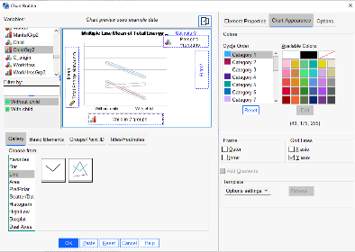

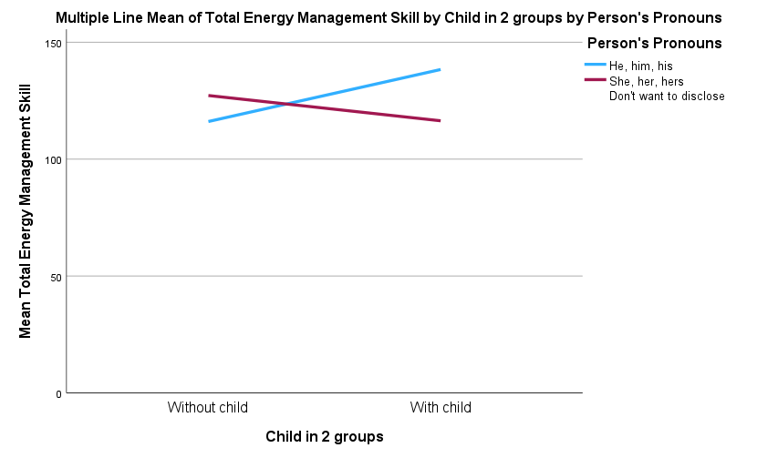

Additionally, we decompose the “child” group by gender. We find that women get a higher score for total energy management skills scores than men for respondents without children. However, for those with children, men’s total energy management skills scores were higher than women’s.

The main takeaway here is the noticeable drop in the energy management skills score of female respondents with children from female respondents who do not have children. Intuitively, this shows that women’s time and energy are disproportionately impacted by having children than men and suggests that women still carry the heavier burden of childcare than men. It also implies that traditional gender roles still hold, at least when it comes to childcare. On the other hand, we see that male respondents with children also had an equally noticeable jump in their energy management skills score from male respondents who do not have children. While there could be multiple reasons and interpretations on why this is so, it could be the case that men with children, who are less burdened by childcare than their spouses, are taking a healthier, more mature, and more proactive approach in managing their time and energies than when they didn’t have children.

***Energy Management Skills of Respondents Per Gender***

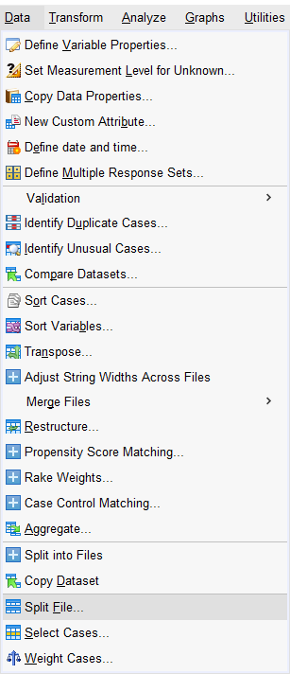 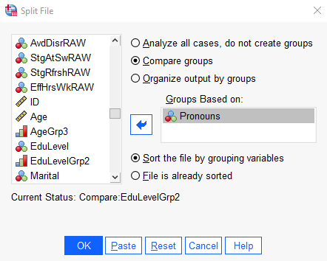

 

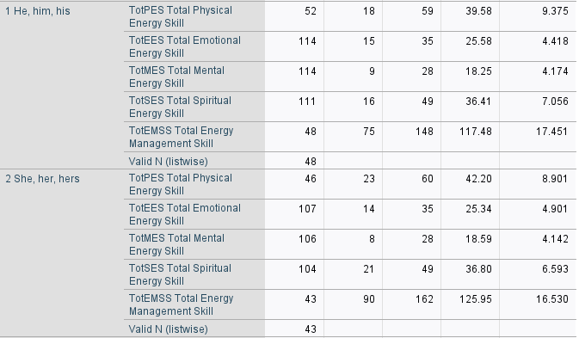

*Graph*

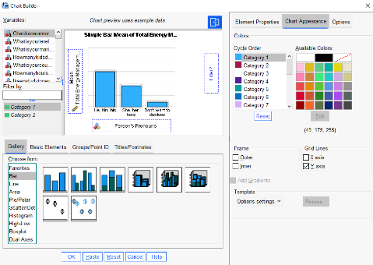

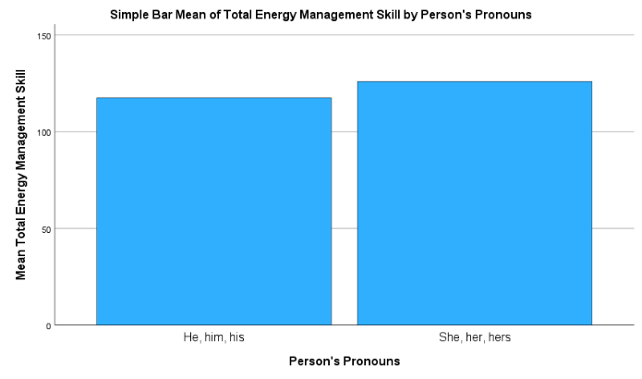

The survey shows that, in general, female respondents have the higher total energy managements skills score than men with a mean score of 125.95. About 8 points behind are male respondents (mean score of 117.48). Among the individual scales, female respondents lead the most in total physical energy skill score. Meanwhile, men have a slightly higher total emotional energy skill score.

***Energy Management Skills of Respondents Per Age Group***

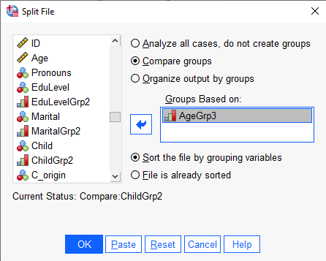

 

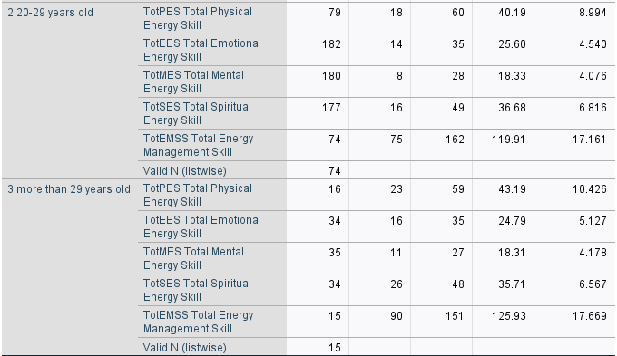

*Graph*

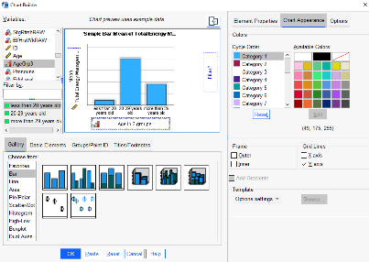

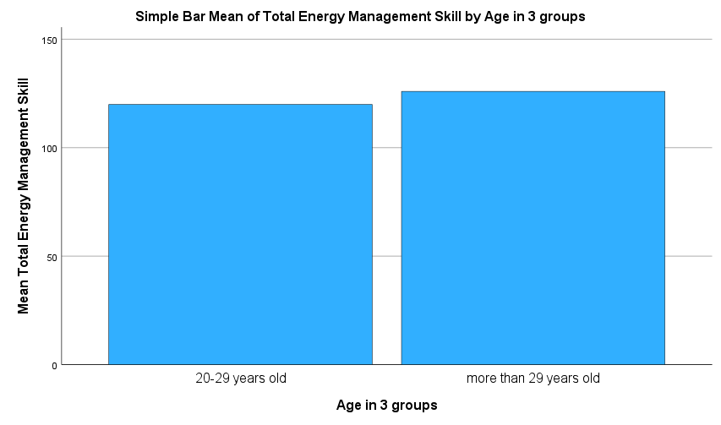

The survey shows that, in general, the more senior respondents have the higher total energy managements skills score than their younger counterparts. Among the individual scales, the total physical energy skill score of respondents aged more than 29 years old is about 3 points more than the score of respondents aged 20-29 years old. All other individual scales show that 20–29-year-olds have a marginally higher score than respondents who are beyond 29 years old. This is somewhat counter intuitive since expectations are for more senior respondents to be more skilled managing their emotional and spiritual energies.

***Energy Management Skills of Respondents Per Education Level***

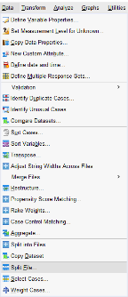  

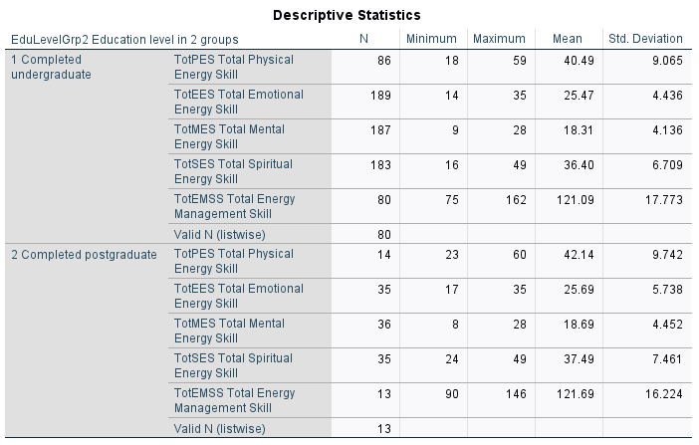

*Graph*

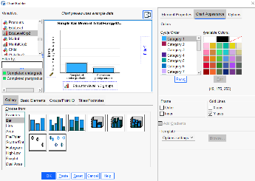

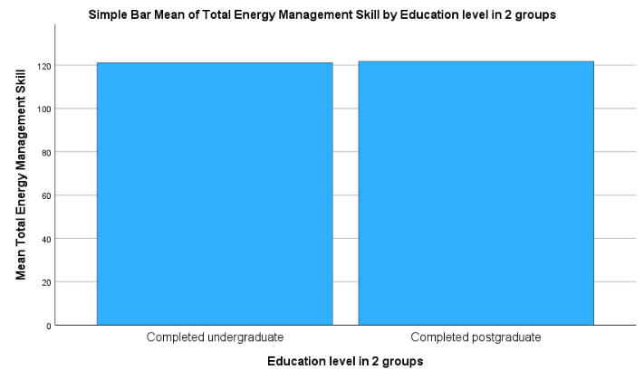

The survey result shows that there is almost no difference in the total energy management skills scores of respondents who completed undergraduate and respondents who finished postgraduate studies.

# **REFERENCES**

Korchagina, N. (2023, August 28). *Recorded Lecture 6* [Video]. Humber College. https://humberital-my.sharepoint.com/personal/n01495795_humber_ca/_layouts/15/stream.aspx?id=%2Fpersonal%2Fn01495795%5Fhumber%5Fca%2FDocuments%2FBIA%205201%20Data%20Analytics%20Tools%201%2FPre%2DRecorded%20Lectures%2FRecorded%20Lecture%206%2Emp4&nav=eyJyZWZlcnJhbEluZm8iOnsicmVmZXJyYWxBcHAiOiJTdHJlYW1XZWJBcHAiLCJyZWZlcnJhbFZpZXciOiJTaGFyZURpYWxvZy1MaW5rIiwicmVmZXJyYWxBcHBQbGF0Zm9ybSI6IldlYiIsInJlZmVycmFsTW9kZSI6InZpZXcifX0&ga=1&referrer=StreamWebApp%2EWeb&referrerScenario=AddressBarCopied%2Eview

Zhang, J., Tong, J., & Huo, D. (2018). Development of the Energy Management Scale. *Social Behavior and Personality, 46* (12), 2081-2096. https://doi.org/10.2224/sbp.7426